Subject: Digital Forensics & Incident Response (DF & IR)

TryHackMe Completed Room’s
TABLE OF CONTENT

Sr No. | TryHackMe Name | Page No
1 | Intro to Digital Forensic | 2
2 | Intro to Cold Forensic Investigation | 5
3 | Disk Analysis and Autopsy | 7
4 | Volatility Essentials | 14
5 | Memory Analysis Introduction

Additional Online Practice – Virtual Labs

Sr No. | Virtual Labs Name | Page No
1 | File Signatures and File Carving Techniques | 17
2 | Memory Forensics: Retrieving Password Hashes and Cached Files | 21
3 | Exploring the Master File Table (MFT) | 24
4 | Data Hiding and Unhiding: LSB Steganography Technique | 27
5 | Identifying and Investigating Network Attacks using Wireshark | 29
6 | Bandit overthewire.org | 30

TryHackMe ROOM 1: Intro to Digital Forensics
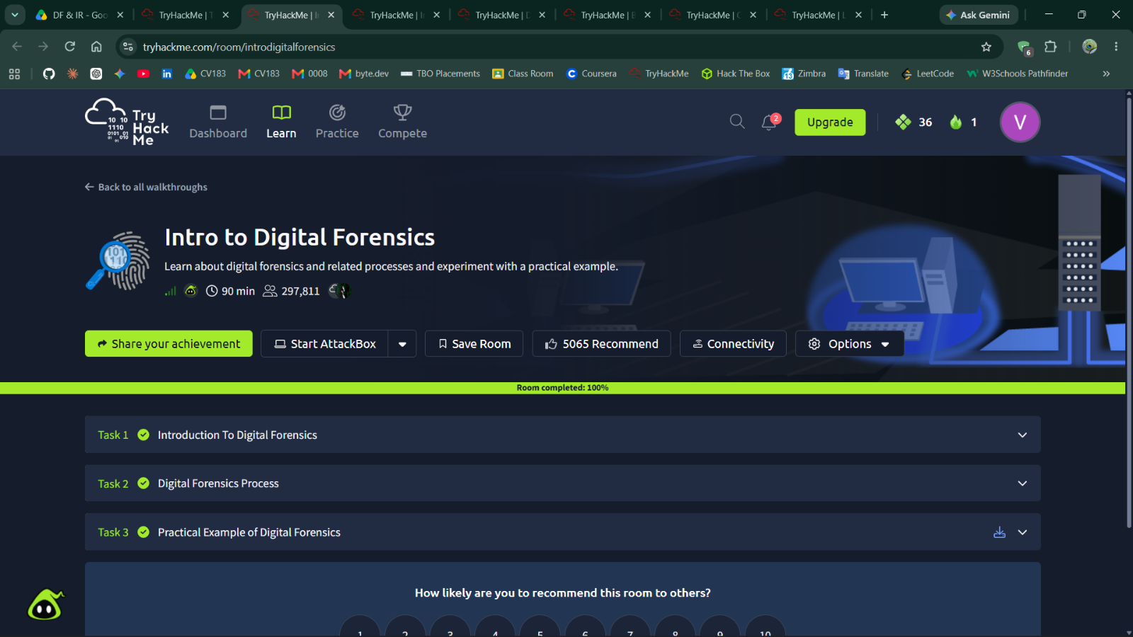
Task 1: Introduction To Digital Forensics
Consider the desk in the photo above. In addition to the smartphone, camera, and SD cards, what would be interesting for digital forensics?

- laptop
Task 2: Digital Forensics Process
It is essential to keep track of who is handling it at any point in time to ensure that evidence is admissible in the court of law. What is the name of the documentation that would help establish that?
- Chain of Custody
Task 3: Practical Example of Digital Forensics
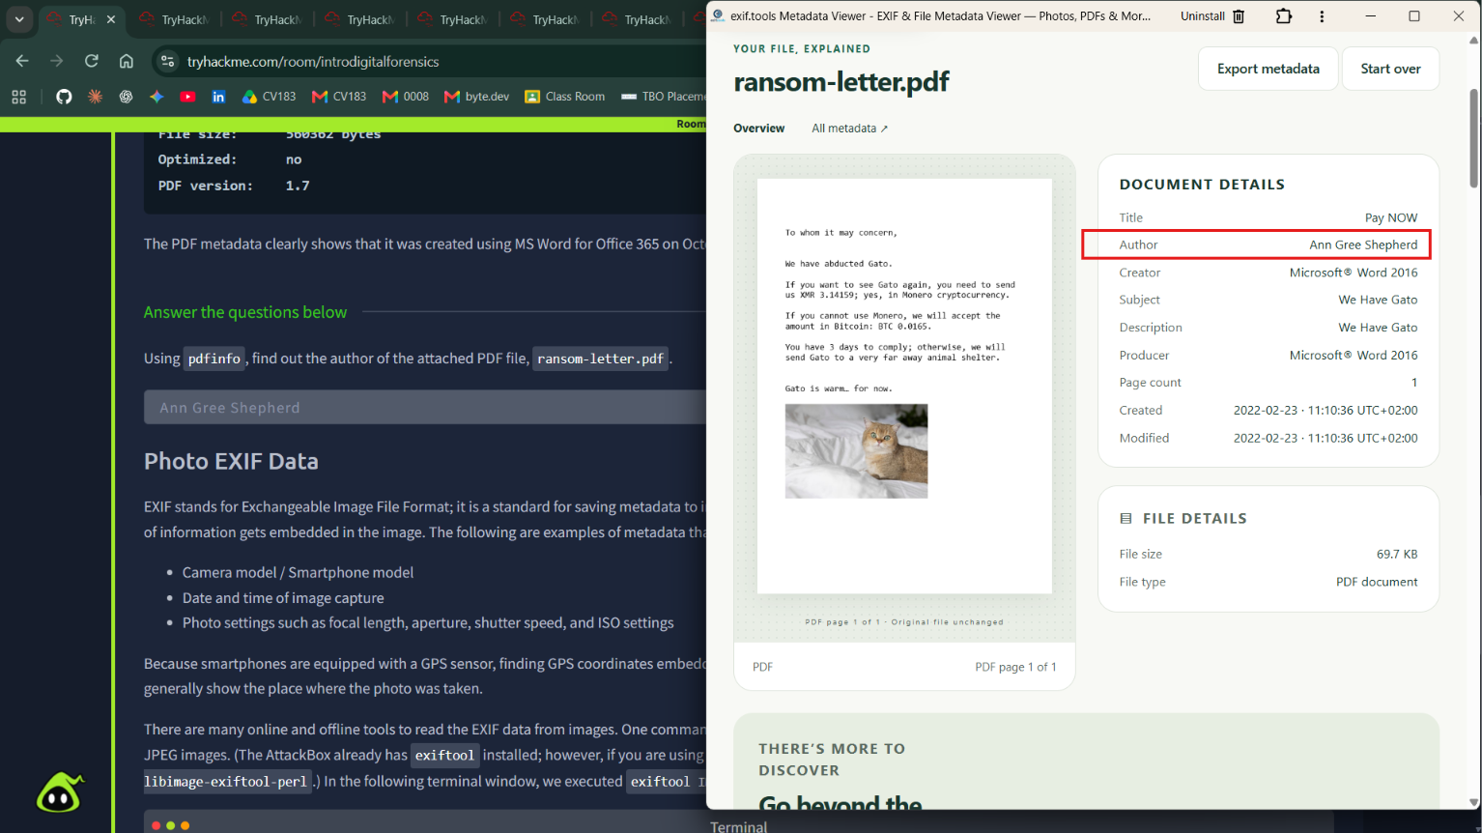
Using pdfinfo, find out the author of the attached PDF file, ransom-letter.pdf.
- Ann Gree Shepherd
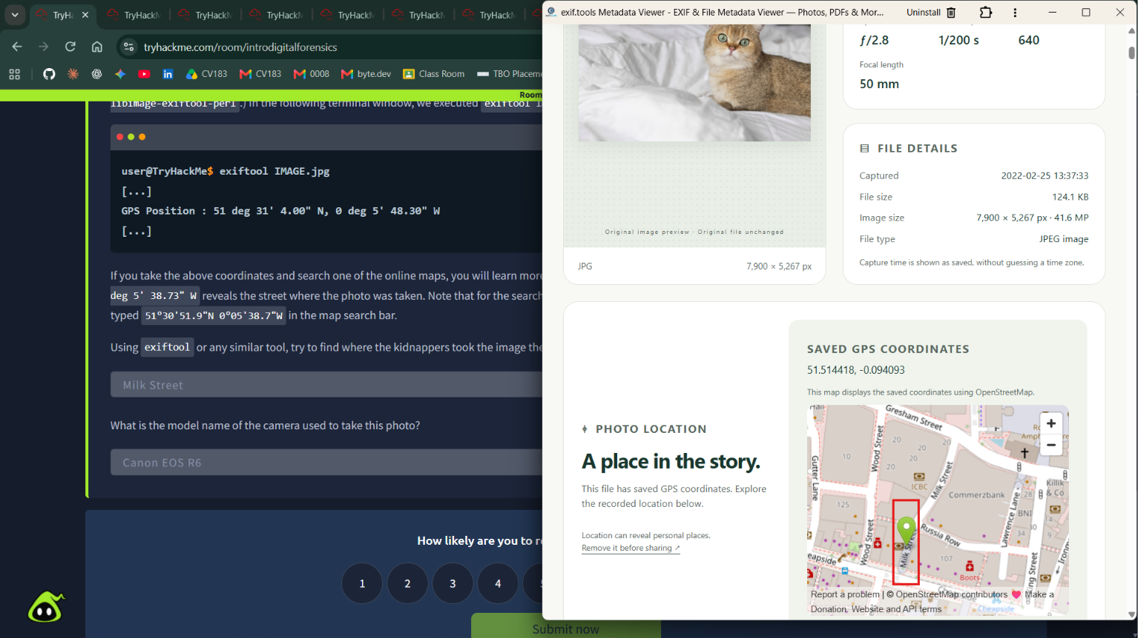
Using exiftool or any similar tool, try to find where the kidnappers took the image they attached to their document. What is the name of the street?
- Milk Street
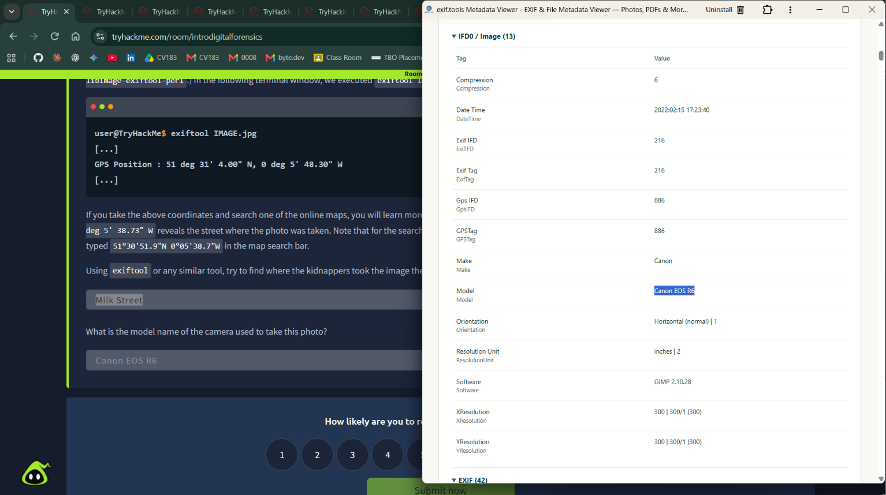
What is the model name of the camera used to take this photo?
- Canon EOS R6

TryHackMe ROOM 2: Intro to Cold System Forensics
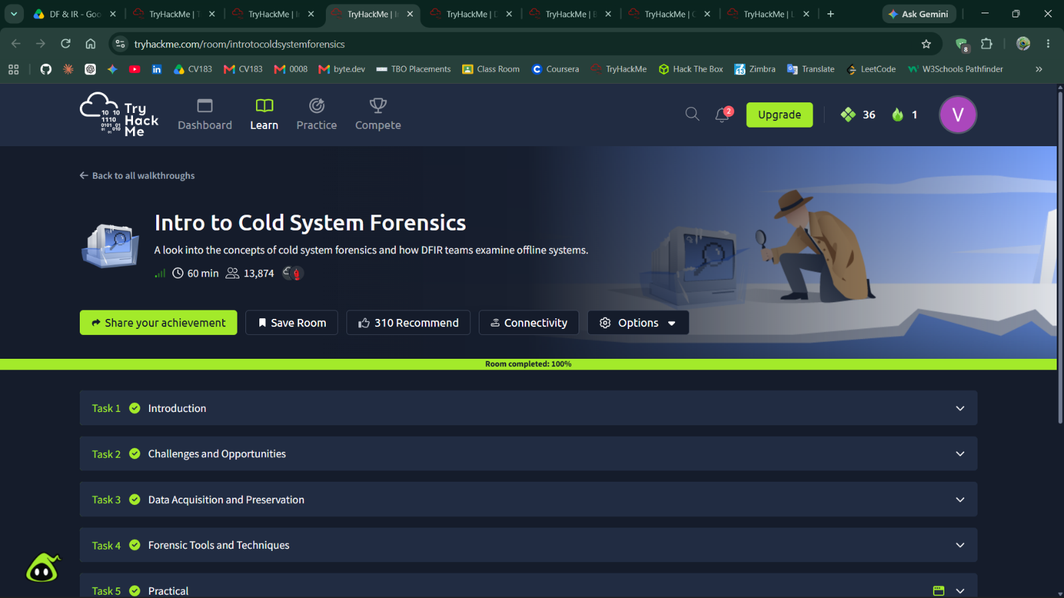
Task 1: Introduction No answer needed
Task 2: Challenges and Opportunities
Under what two system states are cold system forensics mainly applied?

- Dormant or Powered-off

What type of attack provided a research basis for cold system forensics?
- cold boot attack

Task 3: Data Acquisition and Preservation
The making of a bit-by-bit copy of forensic data is known as?
- Disk imaging

What restricts access to sensitive data?
- Access control

Which sources of evidence are part of the most volatile on a host?
- CPU registers and cache

Task 4: Forensic Tools and Techniques
Using hash functions seeks to minimise risks associated with what element?

data integrity

What is the name of the documentation responsible for listing the forensic evidence and its accompanying responsibilities?
- chain of custody
Task 5: Practical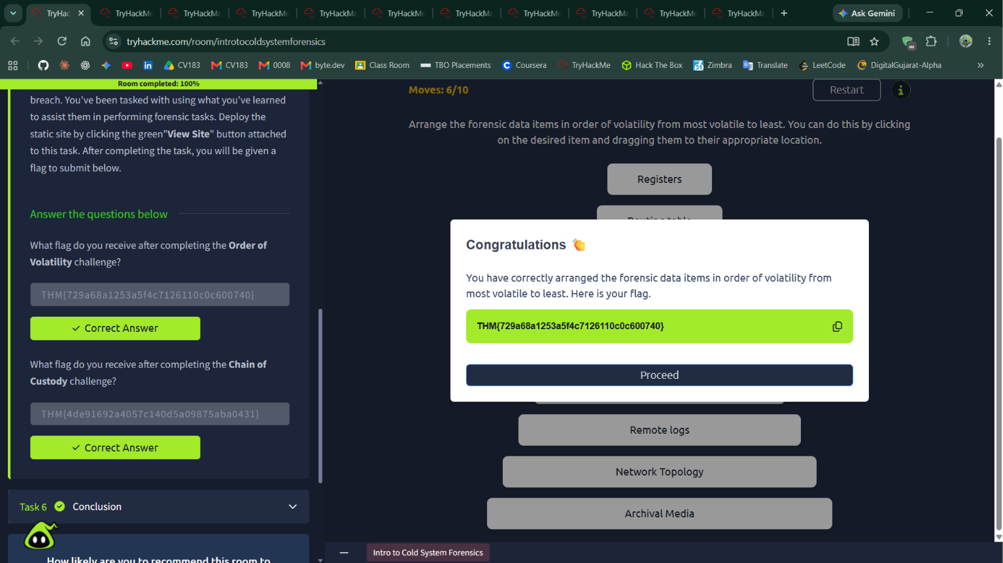
What flag do you receive after completing the Order of Volatility challenge?
- THM{729a68a1253a5f4c7126110c0c600740}
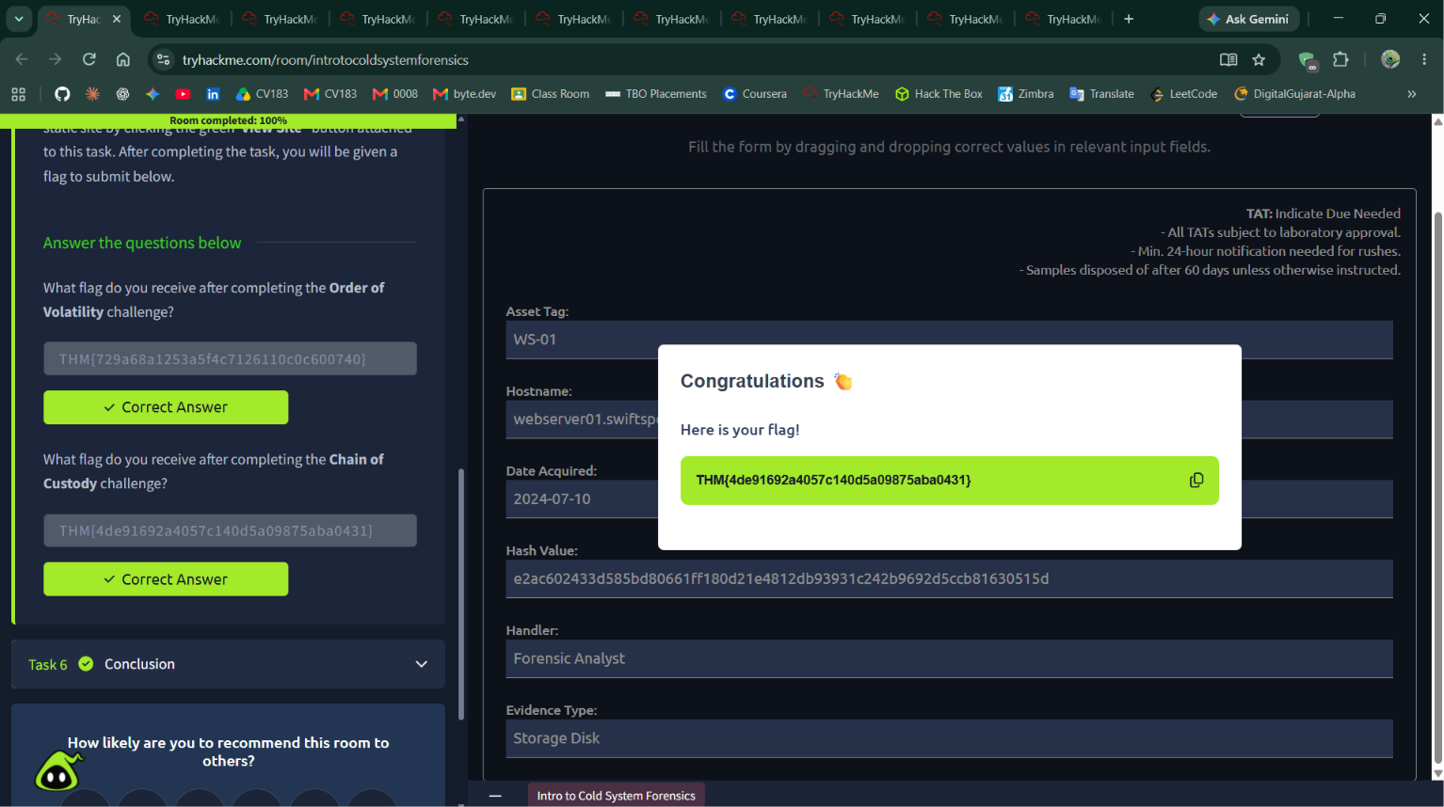
What flag do you receive after completing the Chain of Custody challenge?
- THM{4de91692a4057c140d5a09875aba0431}
Task 6: Conclusion No answer needed
TryHackMe ROOM 3: Disk Analysis & Autopsy
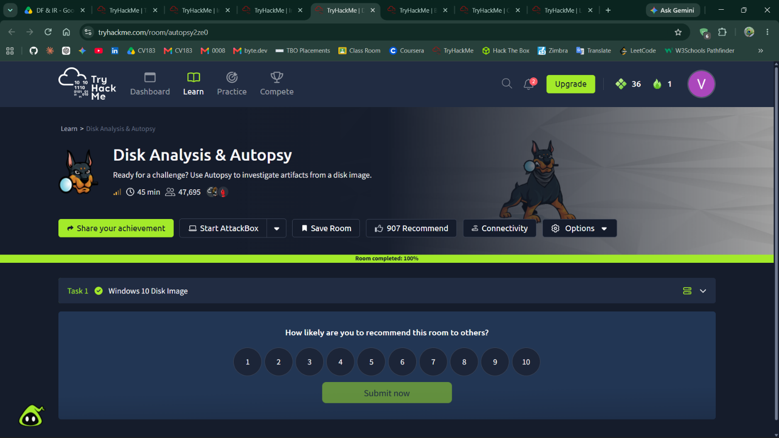
Task 1: Windows 10 Disk Image

What is the MD5 hash of the E01 image?
- 3f08c518adb3b5c1359849657a9b2079

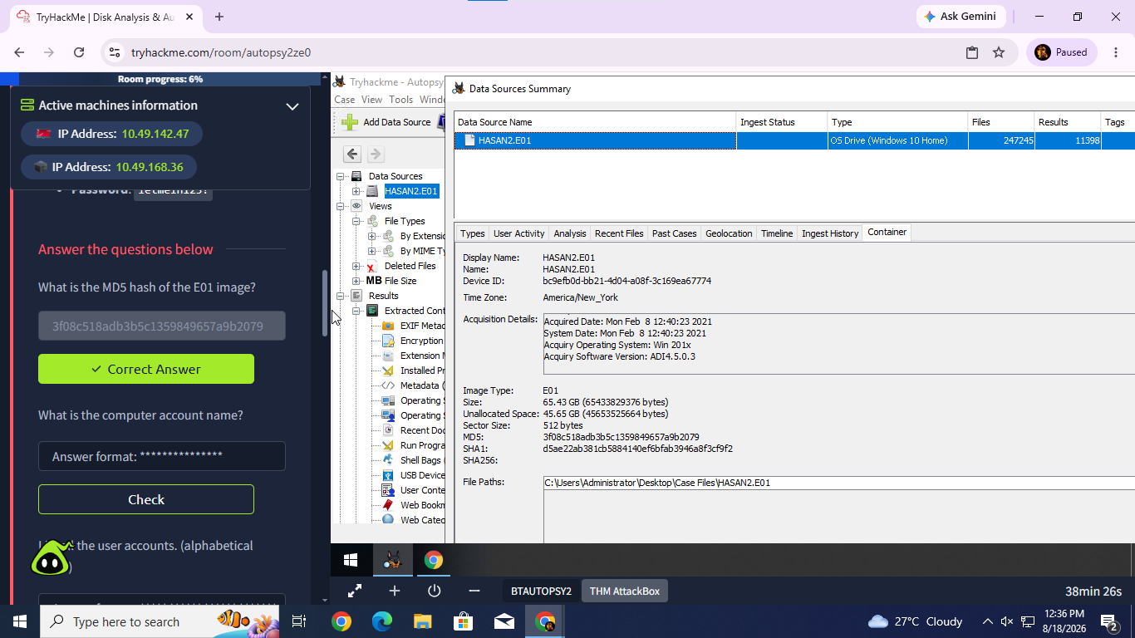

What is the computer account name?
- DESKTOP-0R59DJ3
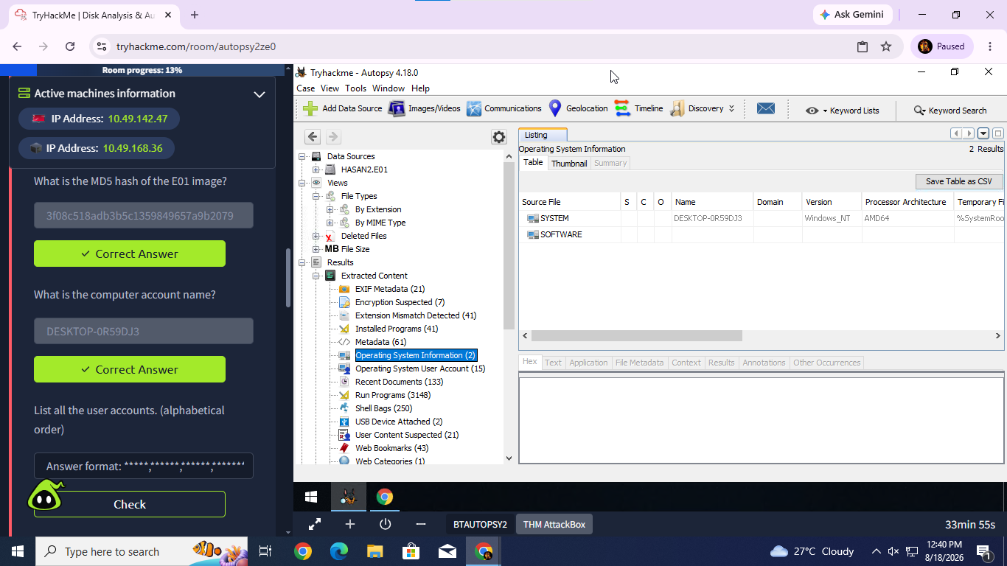

List all the user accounts. (alphabetical order)

- H4S4N,joshwa,keshav,sandhya,shreya,sivapriya,srini,suba

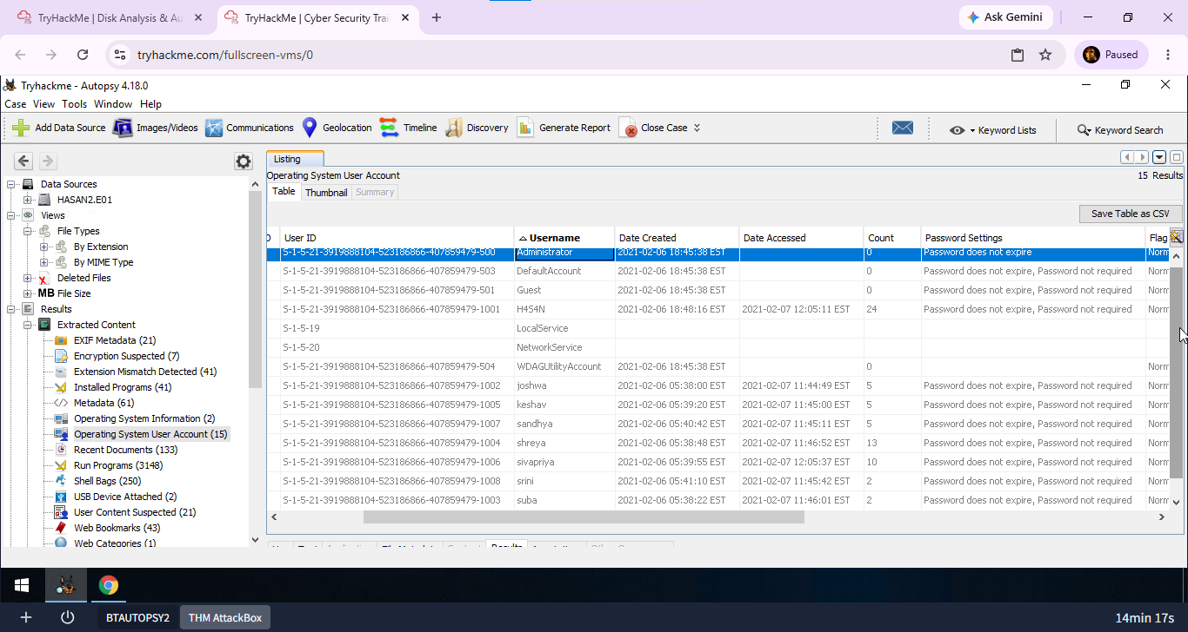

Who was the last user to log into the computer?
- sivapriya
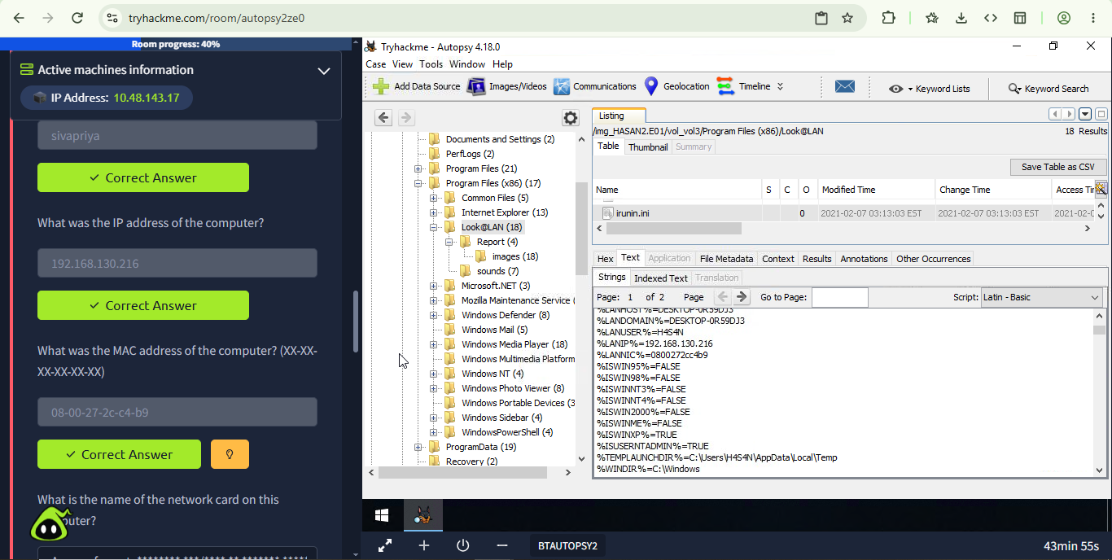

What was the IP address of the computer?
- 192.168.130.216

What was the MAC address of the computer? (XX-XX-XX-XX-XX-XX)
- 08-00-27-2c-c4-b9

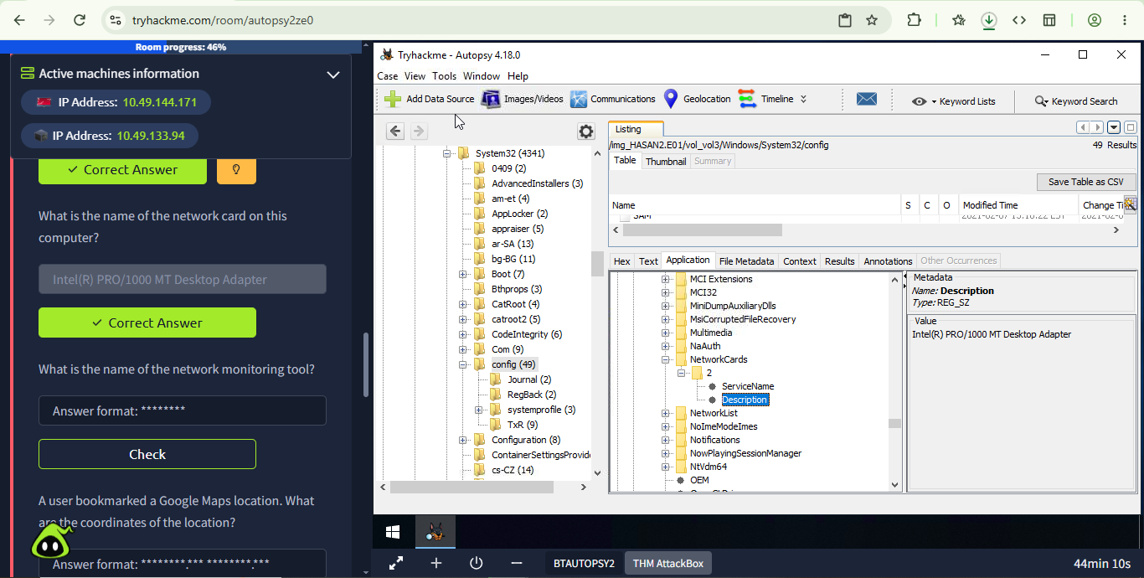

What is the name of the network card on this computer?
- Intel(R) PRO/1000 MT Desktop Adapter

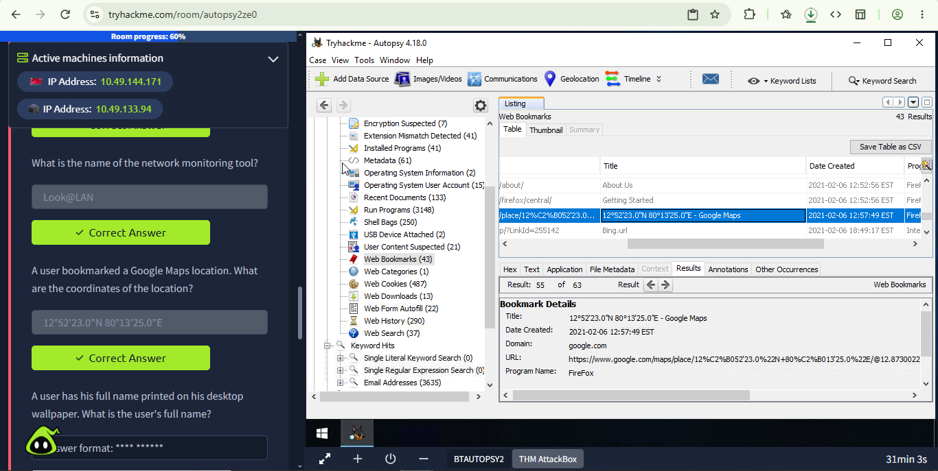

What is the name of the network monitoring tool?
- Look@LAN

A user bookmarked a Google Maps location. What are the coordinates of the location?
- 12°52'23.0"N 80°13'25.0"E

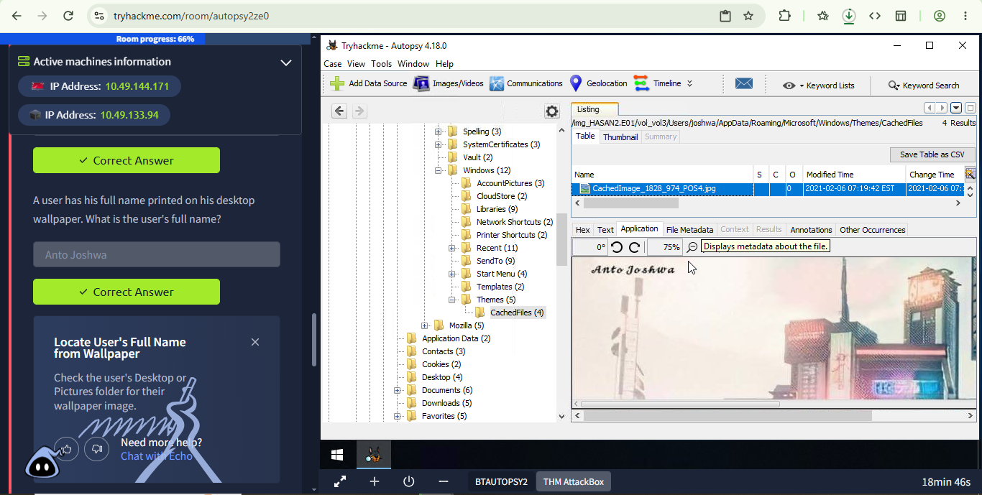

A user has his full name printed on his desktop wallpaper. What is the user's full name?
- Anto Joshwa

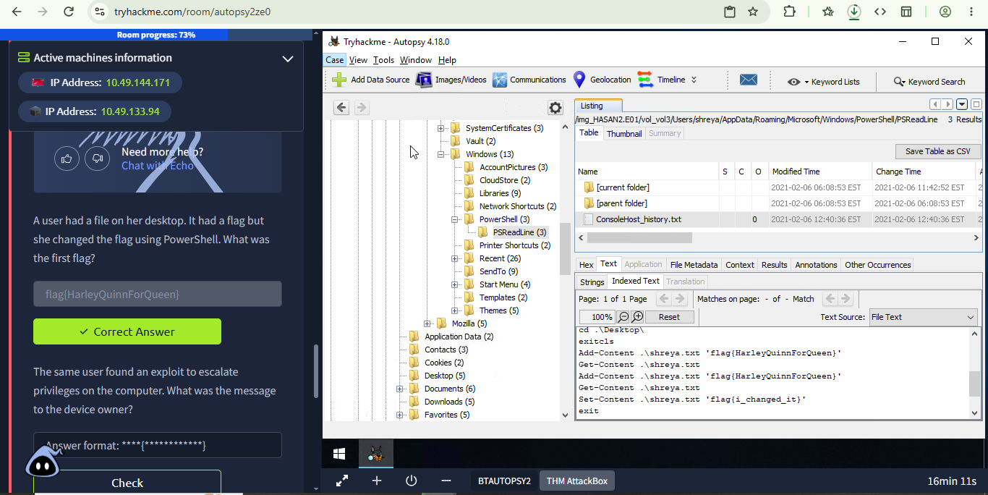

A user had a file on her desktop. It had a flag but she changed the flag using PowerShell. What was the first flag?
- flag{HarleyQuinnForQueen}

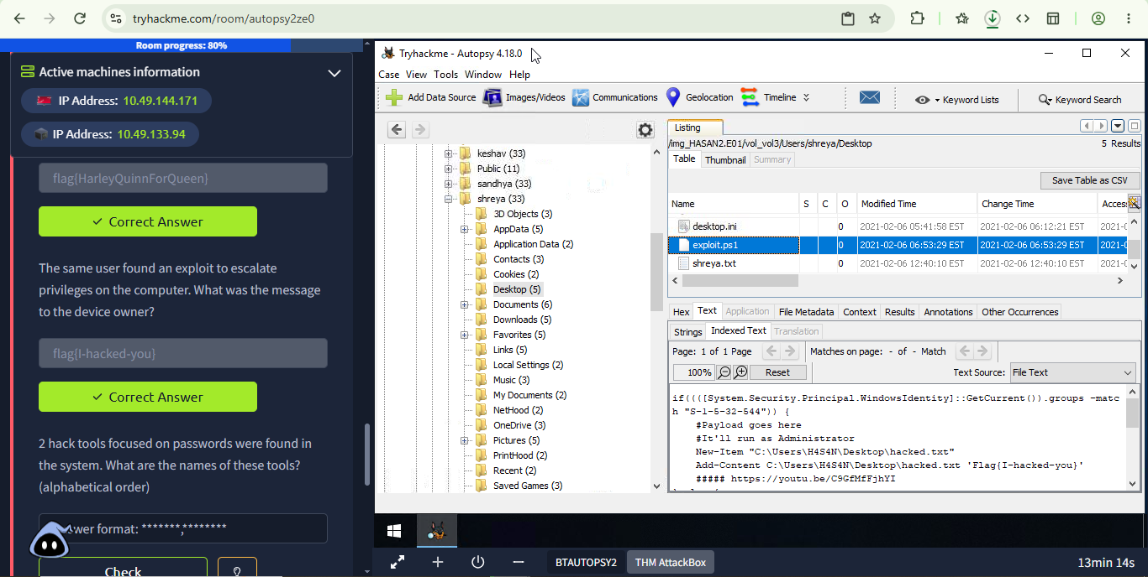

The same user found an exploit to escalate privileges on the computer. What was the message to the device owner?
- flag{I-hacked-you}

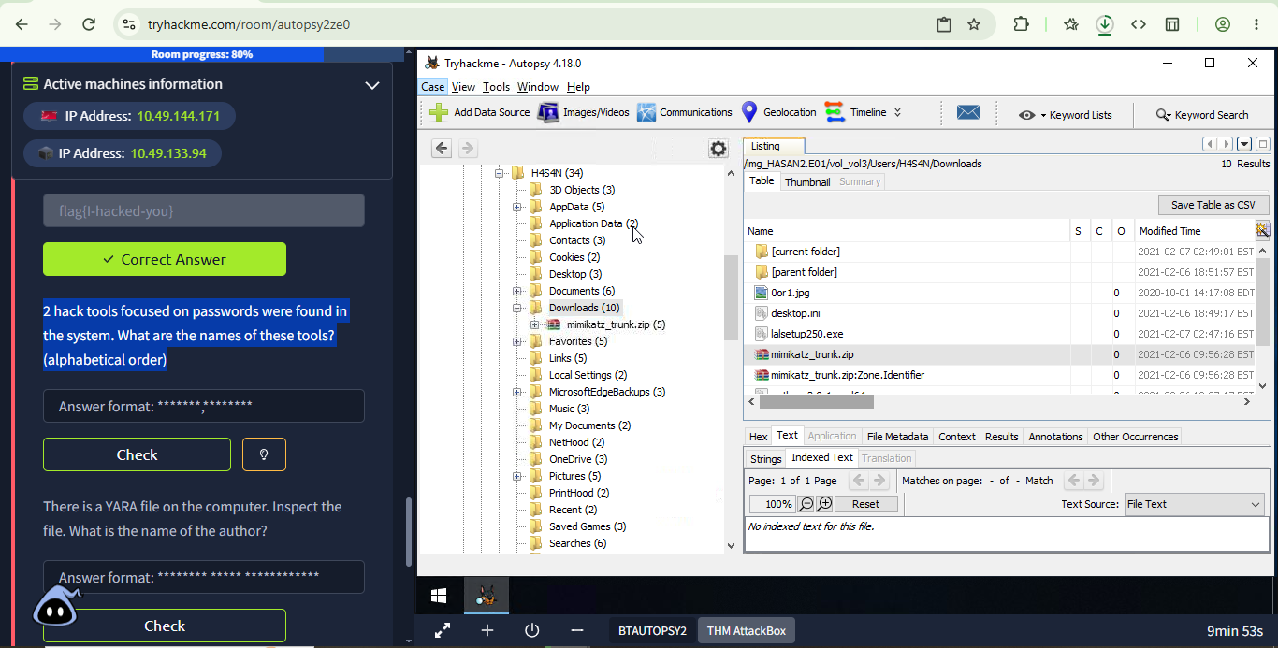
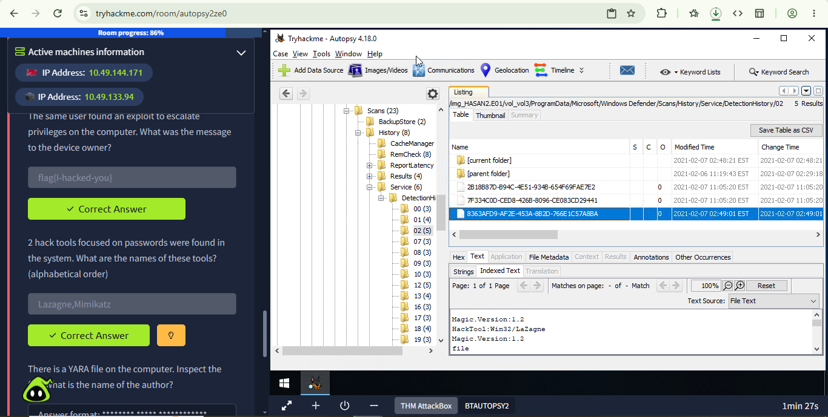

2 hack tools focused on passwords were found in the system. What are the names of these tools? (alphabetical order)
- Lazagne,Mimikatz

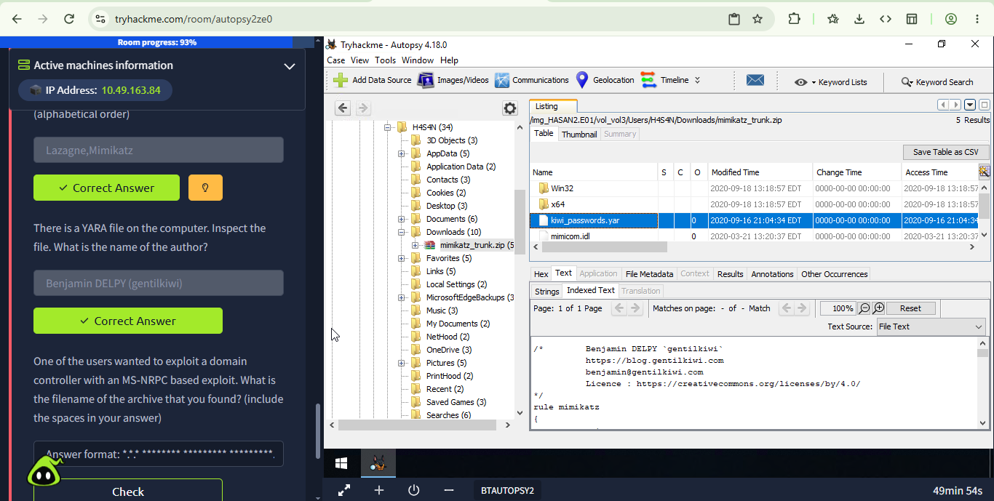

There is a YARA file on the computer. Inspect the file. What is the name of the author?
- Benjamin DELPY (gentilkiwi)

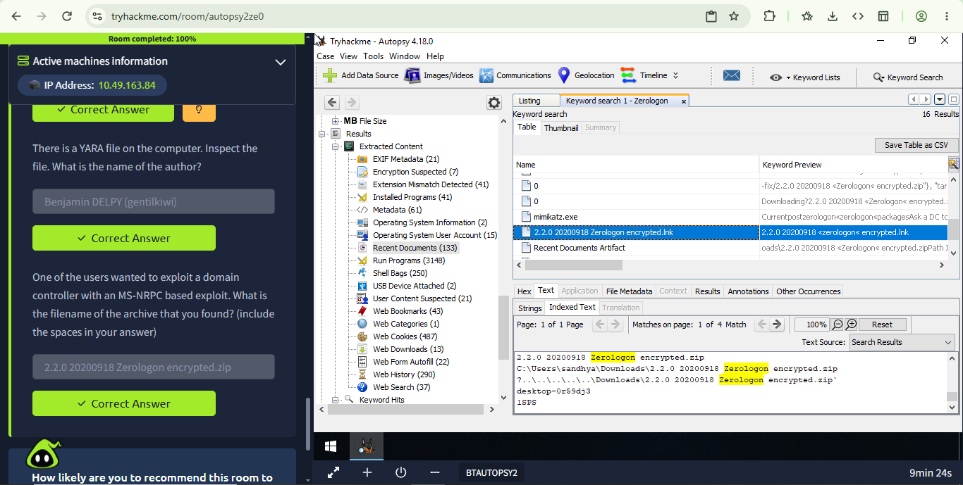

One of the users wanted to exploit a domain controller with an MS-NRPC based exploit. What is the filename of the archive that you found? (include the spaces in your answer)
- 2.2.0 20200918 Zerologon encrypted.zip

TryHackMe ROOM 4: Volatility Essentials


TryHackMe ROOM 5: Memory Analysis Introduction
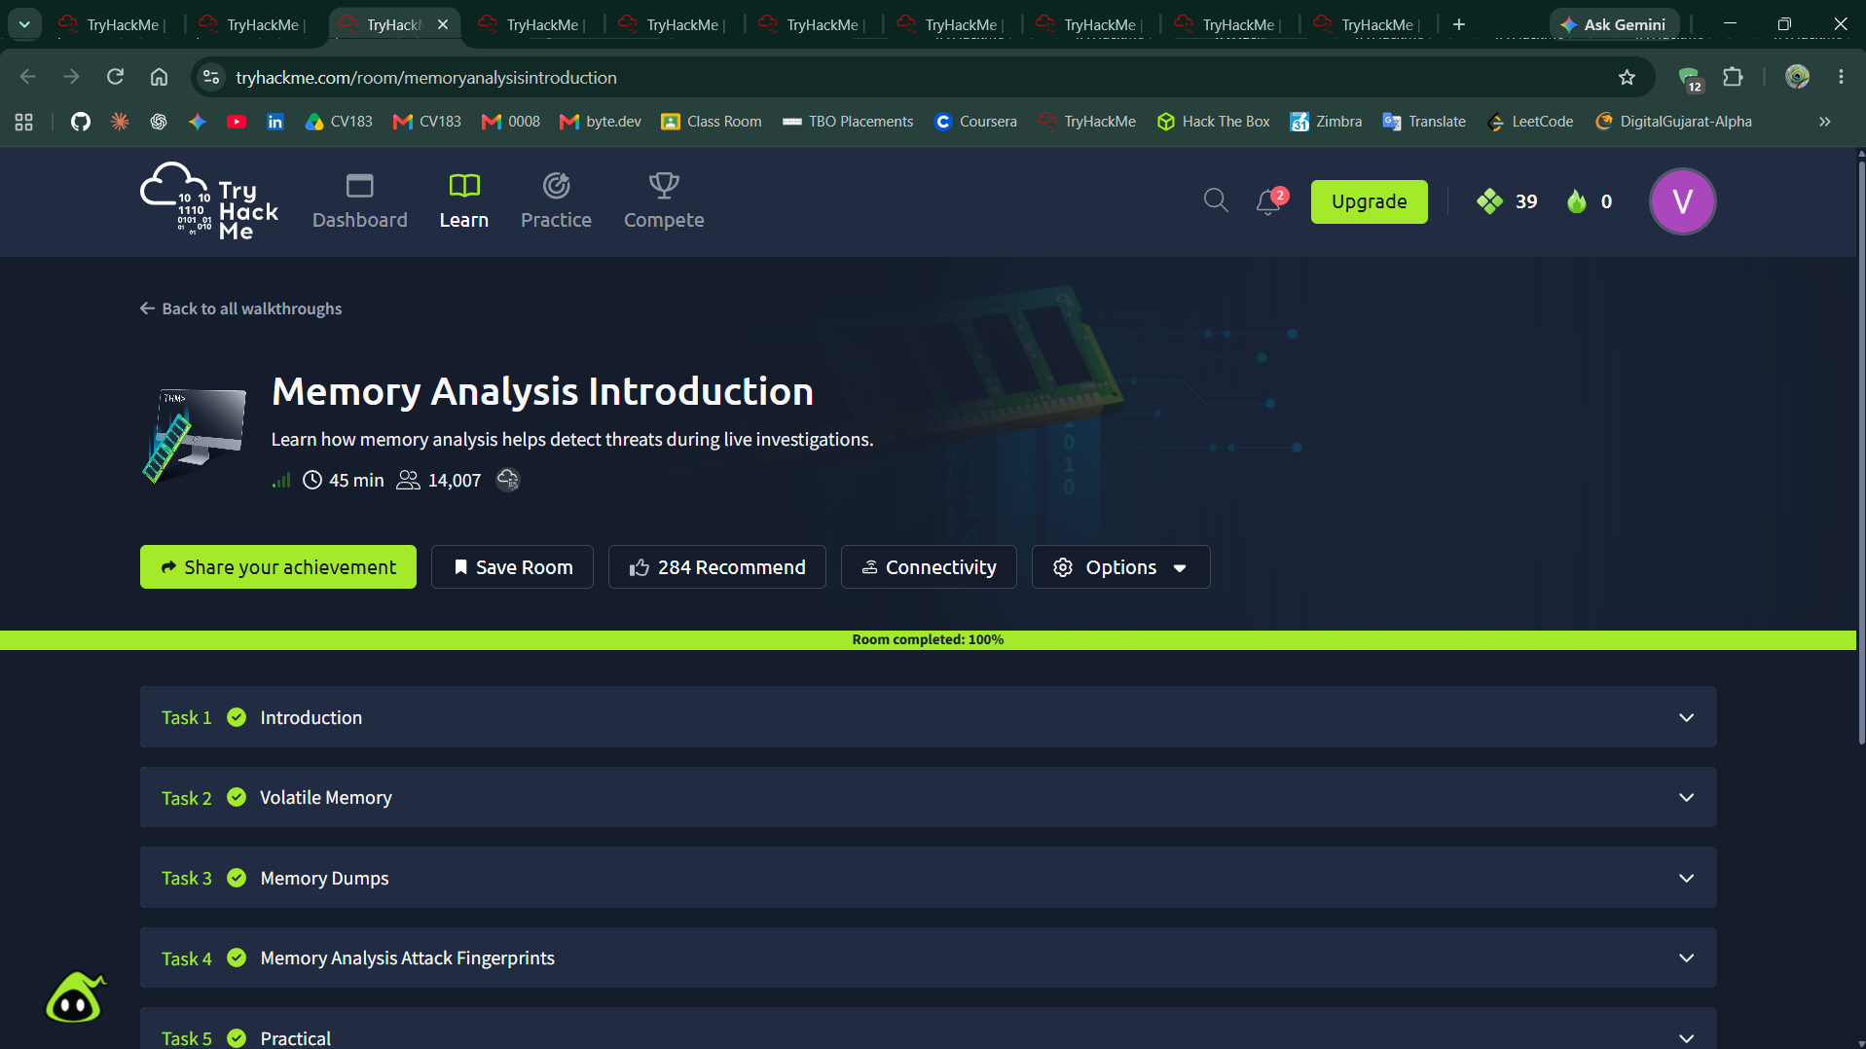
Task 1: Introduction No answer needed

Task 2: Volatile Memory
What type of memory is prioritized because its data disappears after shutdown?
- RAM

What is the slowest component in the memory hierarchy?
- Disk

Which memory region typically contains dynamically allocated data like encryption keys?
- heap

What disk-based area temporarily stores RAM data when memory is full?
- swap

Task 3: Memory Dumps
What tool is commonly used by attackers to extract credentials from memory?

- Mimikatz
What type of memory dump captures all RAM, including user and kernel space?
- full
What Linux tool can be used to extract memory for forensic purposes?

- lime
Which file on Windows systems stores memory during hibernation?
- hiberfil.sys

What anti-forensics technique hides processes by altering kernel structures?

- DKOM

Task 4: Memory Analysis Attack Fingerprints
What technique involves replacing a trusted process’s memory with malicious code?

- Process hollowing

Which Windows service provides PowerShell remoting?

- WinRM

What MITRE technique ID is associated with in-memory PowerShell execution?

- T1086

What command-line tool enables remote execution and is linked to lateral movement (T1021.002)?

- PsExec

Which MITRE technique involves setting tasks that persist through reboots (e.g., schtasks.exe)?
- T1053.005

Task 5: Practical
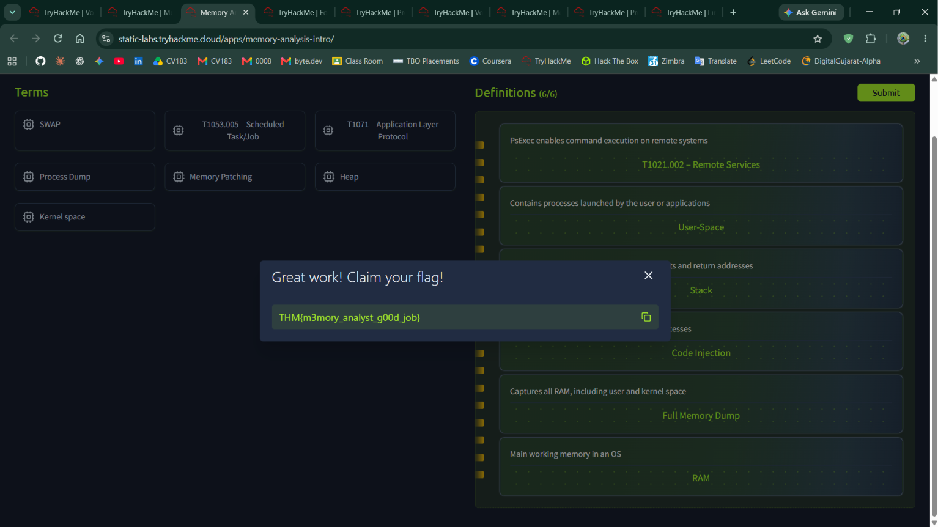
What is the value of the flag?
- THM{m3mory_analyst_g00d_job}

Task 6: Conclusion No answer needed

Practical 1: File Signatures and File Carving Techniques

Aim: To study file signatures (magic numbers) and use them to detect header corruption, carve a hidden file out of a host image, and reconstruct a file that was transferred across a network.

Theory
Every file format begins with a fixed sequence of bytes called a file signature or magic number, which lets an operating system or application identify the file's true type regardless of its extension. In digital forensics, signatures are used to detect files whose headers have been deliberately altered (header corruption), to carve embedded files out of a larger container such as a disk image, and to reconstruct files from fragments captured in network traffic. These techniques are widely used in evidence recovery, corrupted-data recovery, steganalysis, and network-traffic based investigations.

Pretect
What is the primary purpose of a file signature?
a: To provide a unique identifier for a file type
Which of the following file types is not commonly identified by its file signature?
a: .txt
In the context of file carving, what is the first step you should take when attempting to extract a file?
b: Identify the file signature
What is another common name for a file signature?
c: Magic number
Where is the file signature usually found within a file?
c: At the beginning of the file
Why might file signatures be more reliable than file extensions when identifying file types?
c: They are embedded in the file’s content

Simulation:
Header Corruption
- Selected the image (chipmunk photo) — original file signature: FF D8 (JPEG)
- Step-1: Modified the header bytes from FF D8 to DF D7 → image corrupted, no longer recognized as a valid JPEG
- Step-2: Entered the correct signature FF D8 and clicked Fix → image successfully restored
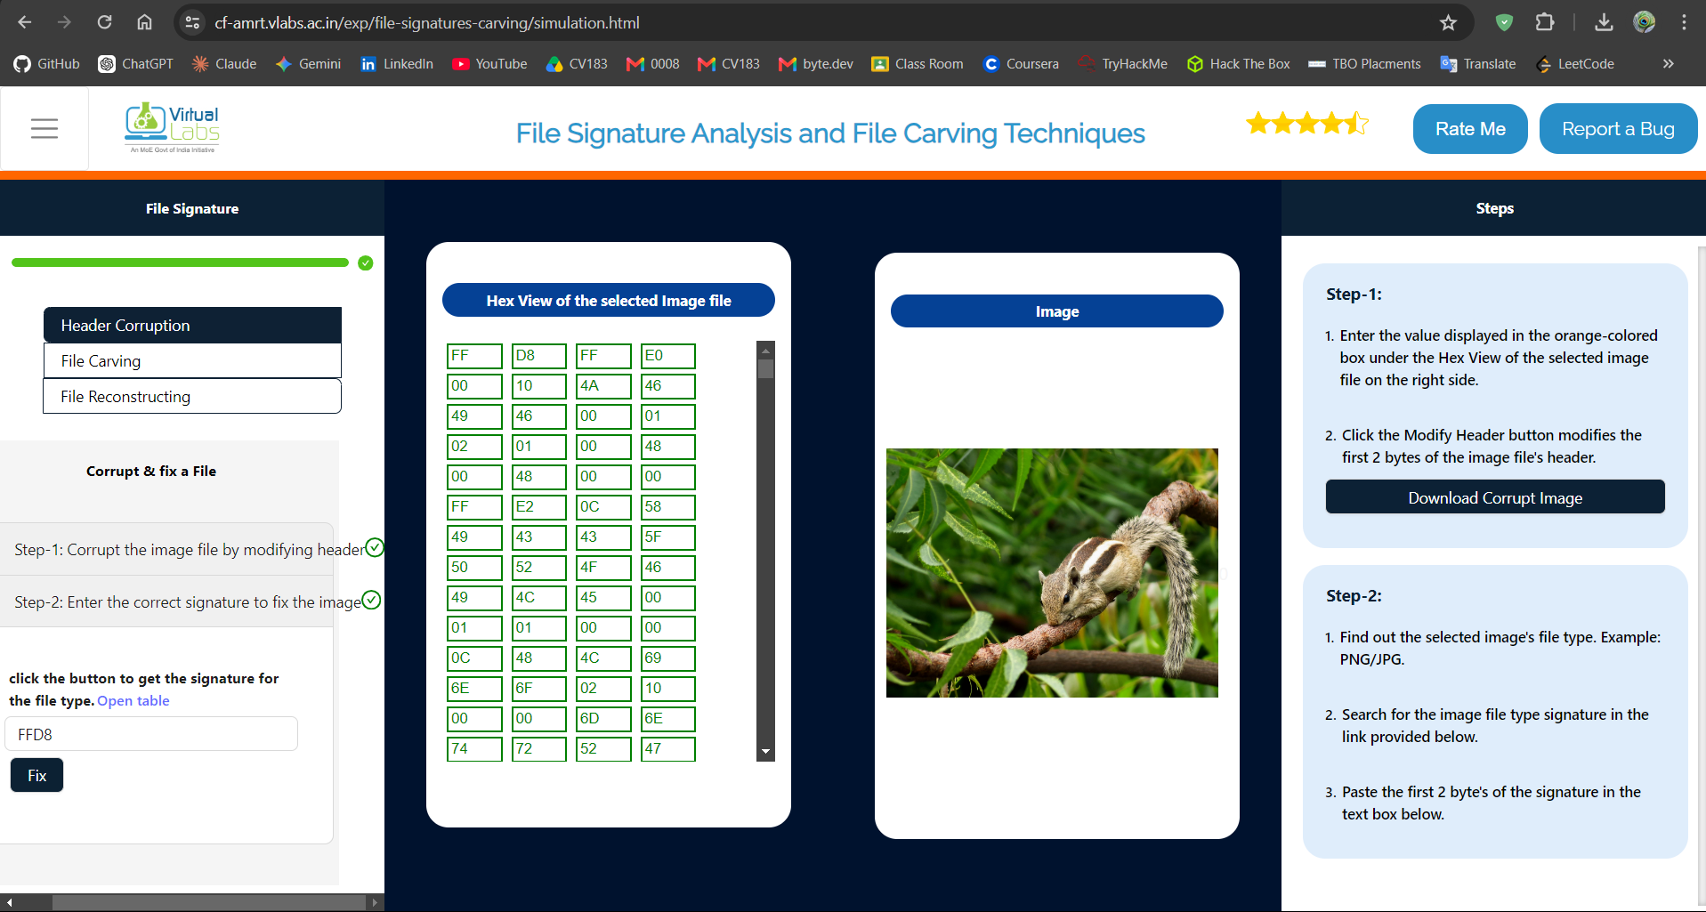
File Carving
- Entered the text Vishal to hide, ticked "Hide to Zip", clicked Hide → text embedded as a ZIP inside Image-2.jpg
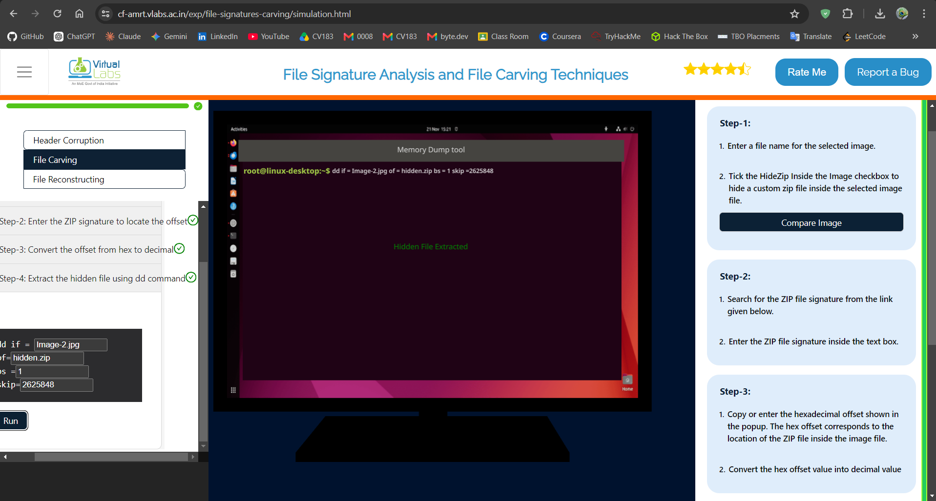
- Entered the ZIP file signature 504B0304 and clicked Locate File → offset found: 00281138 (hex)
- Converted offset to decimal: 00281138 (hex) = 2625848 (decimal)
- Ran the command: dd if=Image-2.jpg of=hidden.zip bs=1 skip=2625848
hidden ZIP file successfully extracted (message: "Hidden File Extracted")

File Reconstruction (Network Capture)
- Selected file type .png, clicked Start Capturing, then Transfer
- In the VLabs Network Capture Tool, observed the FTP-DATA packet carrying the file (STOR putty.png, 14654 bytes) between 192.168.88.100 and 192.168.88.200
- Clicked "Reconstruct PNG file" → file successfully reconstructed from the captured packets
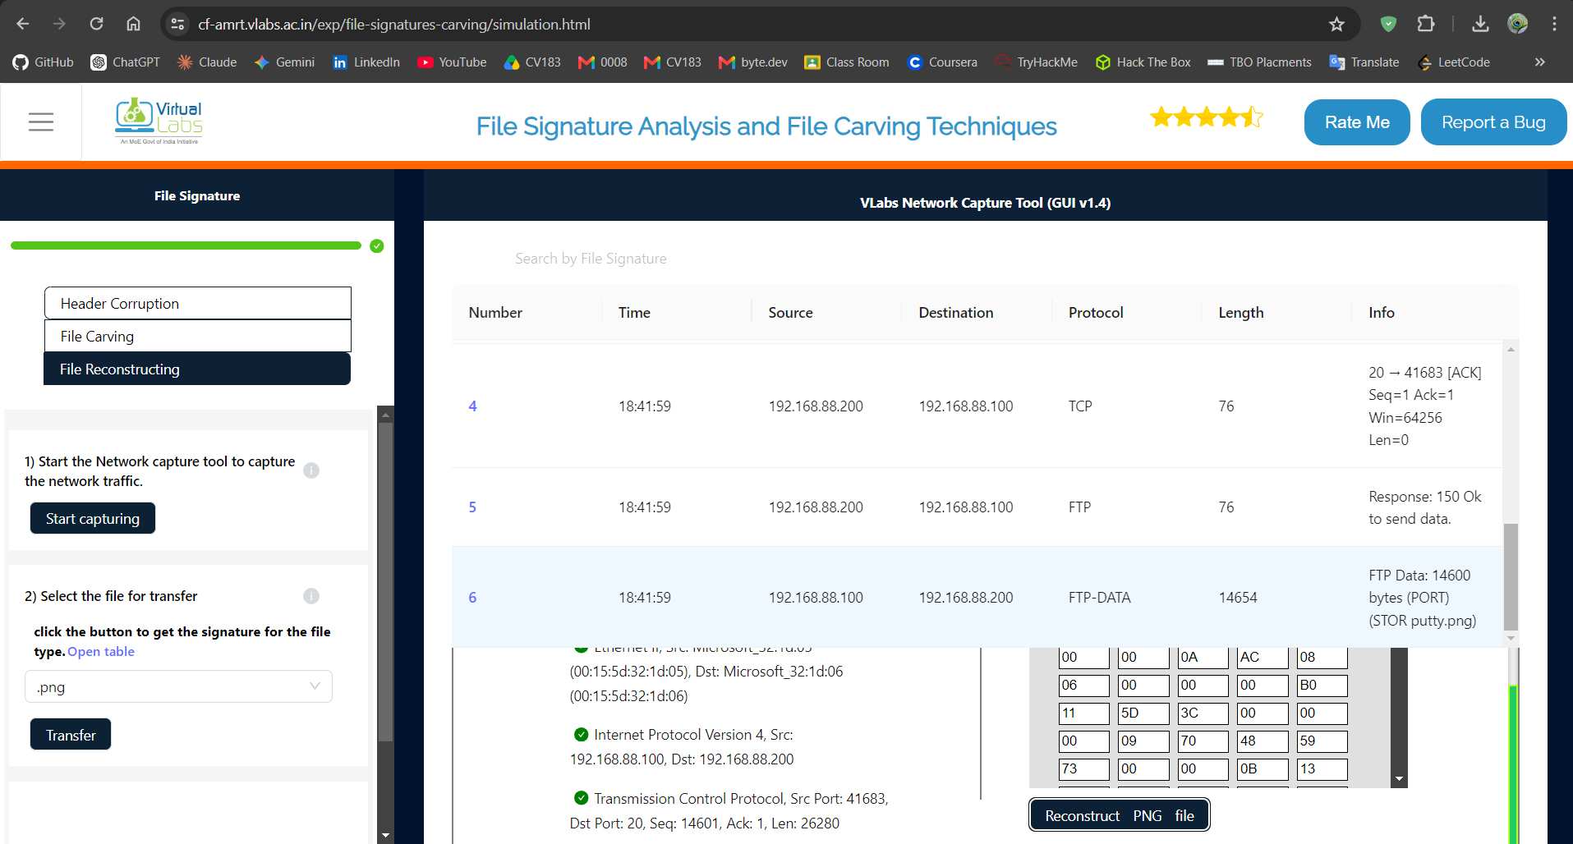

Posttest:
After identifying a file signature in a traffic dump, what is the next step in reconstructing the file?
b: Export the raw data bytes associated with the signature
When fixing a corrupted image header, why is it important to use the correct file signature?
a: The correct signature ensures that the file opens with the right application
In the context of file carving from an image file, what does the 'offset' refer to?
b: The location of the embedded file within the image
Which part of a file typically contains the file signature?
c: Header
What makes file signatures a reliable method for identifying file types?
b: They are embedded in every file and follow standard patterns
Which of the following is an example of a file signature for a PNG file?
c: 89 50 4E 47 0D 0A 1A 0A
Why is it important to know multiple file signatures for the same file format, such as JPEG and JPEG 2000?
a: Different versions of file formats use different signatures
In memory forensics, how are unique patterns constructed to identify memory-mapped files?
b: By analyzing the size and arrangement of operating system object structures
Which file signature would you expect when recovering a RAR-compressed file from raw storage?
a: 52 61 72 21 1A 07 00
Why is relying solely on file extensions insufficient when analyzing unknown files?
a: Extensions can be easily altered and may not match the file's true format
When recovering files from corrupted storage, why is it essential to analyze both headers and footers?
b: Because some file formats require matching start and end markers for accurate recovery

Conclusion:
All three sub-tasks were completed successfully — a corrupted JPEG header was identified and repaired, a hidden ZIP file was located and carved out of an image using its byte offset, and a PNG file was reconstructed from captured network traffic.

Practical 2: Memory Forensics: Retrieving Password Hashes and Cached Files

Aim
To perform memory forensics on a RAM dump — locating OS profile information, extracting SAM/SYSTEM registry hive offsets, dumping password hashes, and cracking a recovered hash.

Theory
RAM is volatile but, while a system is running, it holds artefacts that never touch disk — plaintext fragments, cached credentials and password hashes. Tools built on the Volatility framework parse a memory dump to identify the source operating system (imageinfo), locate the SAM and SYSTEM registry hives in memory, and extract the stored password hashes (hashdump). Because Windows never stores plaintext passwords, an examiner cracks the recovered NTLM/LM hash offline to recover the actual password. This is central to incident response and credential-theft investigations.

Pretest:
What is a Volatility Framework? It is a ?
b: Memory analysis too
Is there a possibility to extract files from RAM?
a: yes
Do you know if Windows registry caches the hashed passwords in its hives?
a: yes
What is typically stored in RAM during system operation?
a: Files currently being used
What is a memory dump?
b: A copy of data stored in RAM
Which of the following is a common use of memory forensics?
b: Recovering active session data
Simulation:
Retrieving Account
- Created the memory.dump file using the MemoryDump tool and transferred it to the forensic system.
- Analysed the memory dump using Volatility imageinfo and identified the OS profile as Win7SP1x64.
- Listed the Windows Registry hives using hivelist and identified the SYSTEM hive at 0xfffff8a000022010 and SAM hive at 0xfffff8a0016a7420.
- Extracted the password hash using hashdump with the SYSTEM and SAM offsets. The hash obtained for GuestUser was 5f4dcc3b5aa765d61d8327deb882cf99.
- Entered the extracted hash into the hash-cracking tool → password successfully recovered as HOWAREYOU.
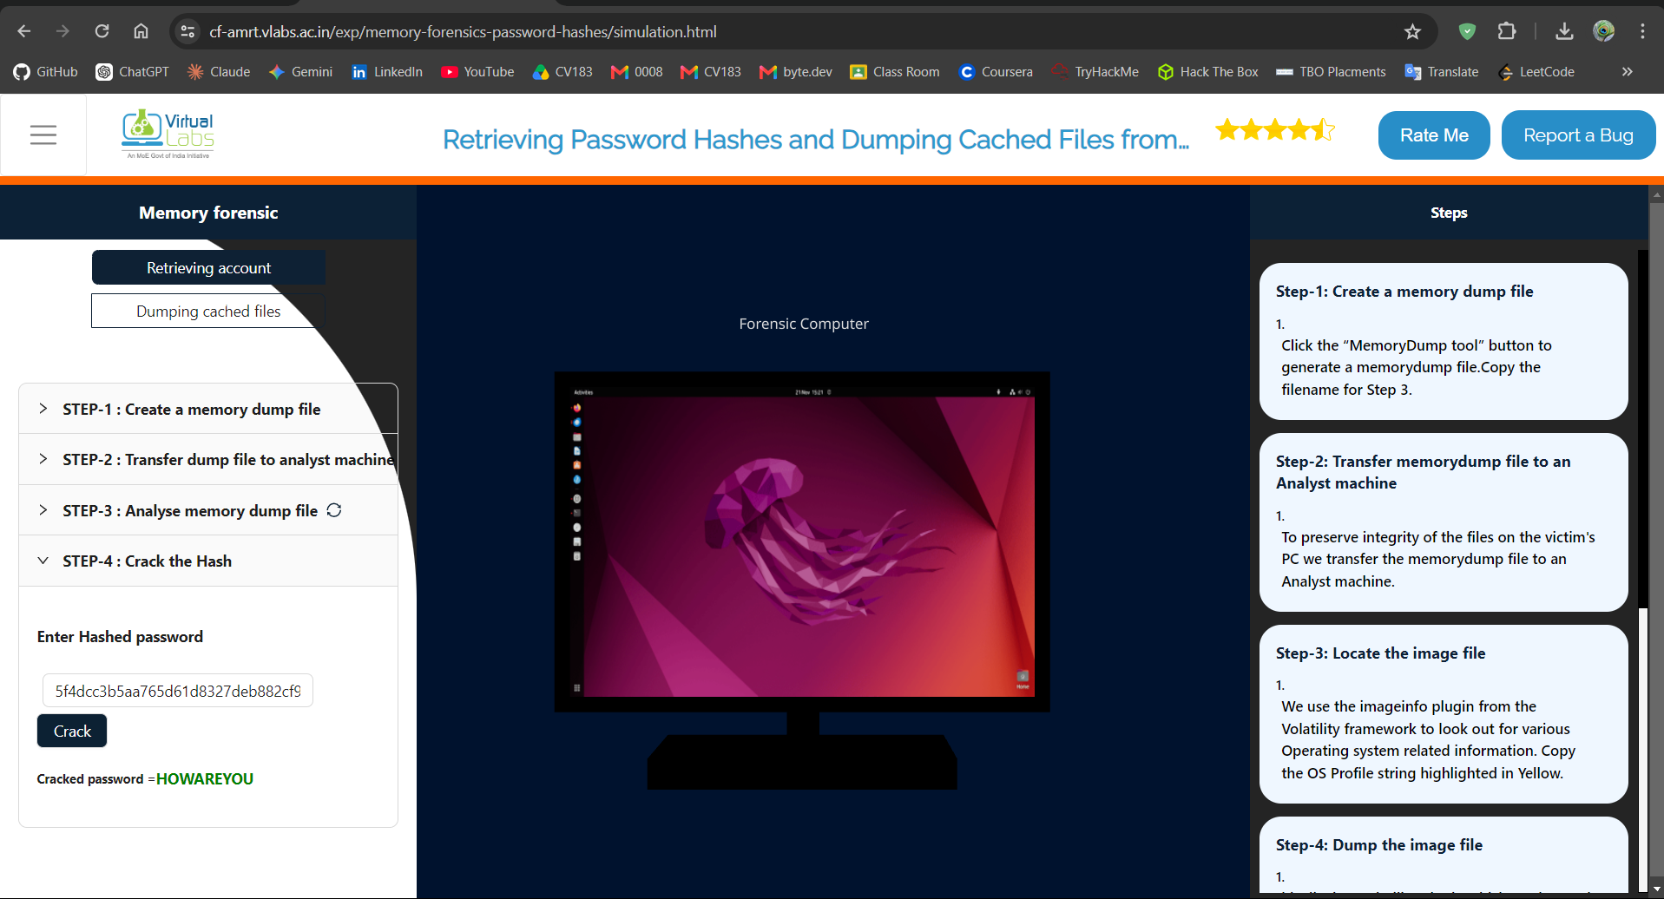
Dumping Cached Files
- Analysed the memory.dump file using Volatility imageinfo and identified the profile as Win7SP1x64.
- Used the filescan command to locate the cached image file C:\config\nature.jpg in the memory dump.
- Identified the file's physical offset as 0x0000000004a41433.
- Ran the dumpfiles command with the identified offset to extract the image file to /opt/.
- Opened the extracted file successfully and viewed the recovered nature.jpg image.
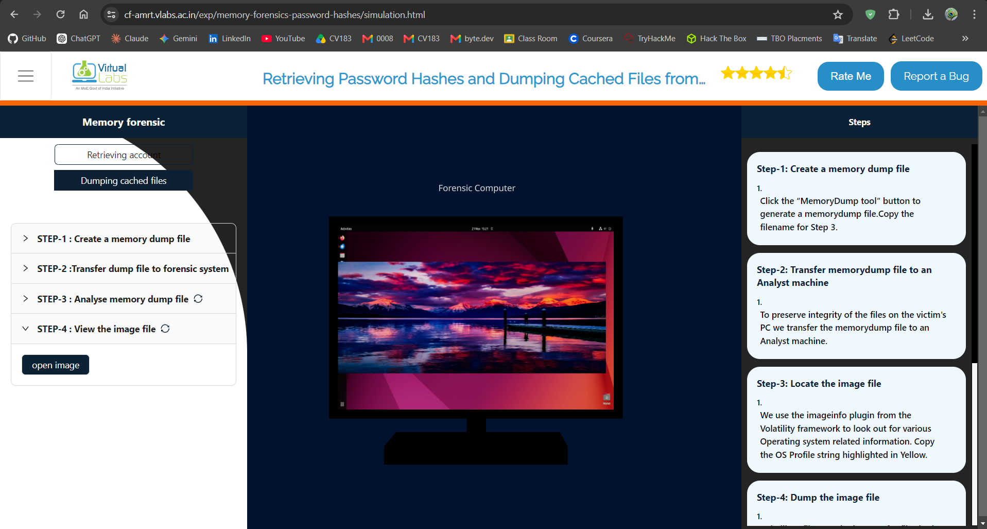
Posttest:
What are Symbol tables?
a: A table with mapping of addresses and human readable names
Is it possible to extract every file present on a file system from a memory dump?
b: no
What type of files are typically recovered during memory forensics?
b: Files that were actively loaded into memory
Which tool is commonly used to analyze memory dumps?
b: Volatility
Why might cached files appear in memory dumps?
b: Because they were recently accessed and kept in memory for performance
Which memory region typically stores process-related data like stack, heap, and code segments?
b: User space memory
In memory forensics, what is the purpose of extracting process lists?
a: To analyze active and terminated processes during the memory snapshot
Which command in Volatility is commonly used to list running processes?
a: pslist

Conclusion:
Text was successfully hidden inside an image by modifying least-significant bits and later recovered intact, confirming the LSB technique preserves visual quality while carrying a hidden payload. The second part showed how the identical technique can be repurposed offensively to smuggle a malicious URL inside an image, underlining why steganalysis is an important part of malware investigation

Practical 3: Exploring the Master File Table (MFT)
Aim
To examine key attributes of the NTFS Master File Table, observe how a deleted resident file's content can still be recovered, and demonstrate writing to and reading from an Alternate Data Stream (ADS).
Theory
The Master File Table is the core NTFS structure that stores metadata — name, size, permissions and timestamps — for every file and directory on a volume, with each object occupying its own MFT entry. Because small ('resident') files can be stored directly inside their MFT entry, their content may still be recoverable even after the file itself is deleted, until the entry is overwritten. NTFS also supports Alternate Data Streams, which let extra data be attached to a file without changing its visible size — a mechanism that is useful for forensic analysis but can also be abused to conceal payloads.
Pretest
What is the primary role of the Master File Table (MFT) in the NTFS file system?
b: To store and track every file and directory on an NTFS volume
Which type of data is typically stored in an Alternate Data Stream (ADS) in an NTFS file system?
c: Hidden or additional data associated with a file
What does the $DATA attribute in an MFT entry represent?
b: The actual content of the file
What is a Resident File in NTFS?
a: A file whose content is stored directly within the MFT record
What happens when a file is non-resident in NTFS?
c: The $DATA attribute stores pointers to its external disk location
Why are MFT attributes important for forensic analysis?
a: They help identify timestamp anomalies and recover deleted files
Simulation
Part A — Simulated Attack Scenario
1. Open Outlook in the simulation and select the email containing a Word-document attachment.
2. Download the attached application.doc file, then close Outlook.
3. Open application.doc — this automatically launches a PowerShell window (simulating a malicious macro).
4. Execute the first PowerShell command; a VBScript runs and creates a desktop.ini file. Use 'Show MFT' to view where this file appears in the MFT.
5. Execute the next command, which writes the marker text 'hjfkhdfbdbfkdfkd' into desktop.ini.
6. Execute the next command, which downloads a shellcode payload via wget and appends it to desktop.ini's Alternate Data Stream (ADS).
7. Execute the next command, which deletes the original desktop.ini file.
8. Execute the step that extracts the MFT offset/content after the deletion.
9. Execute the step that extracts the shellcode from the ADS remnant.
10. Execute the step that runs the extracted shellcode, completing the simulated compromise.
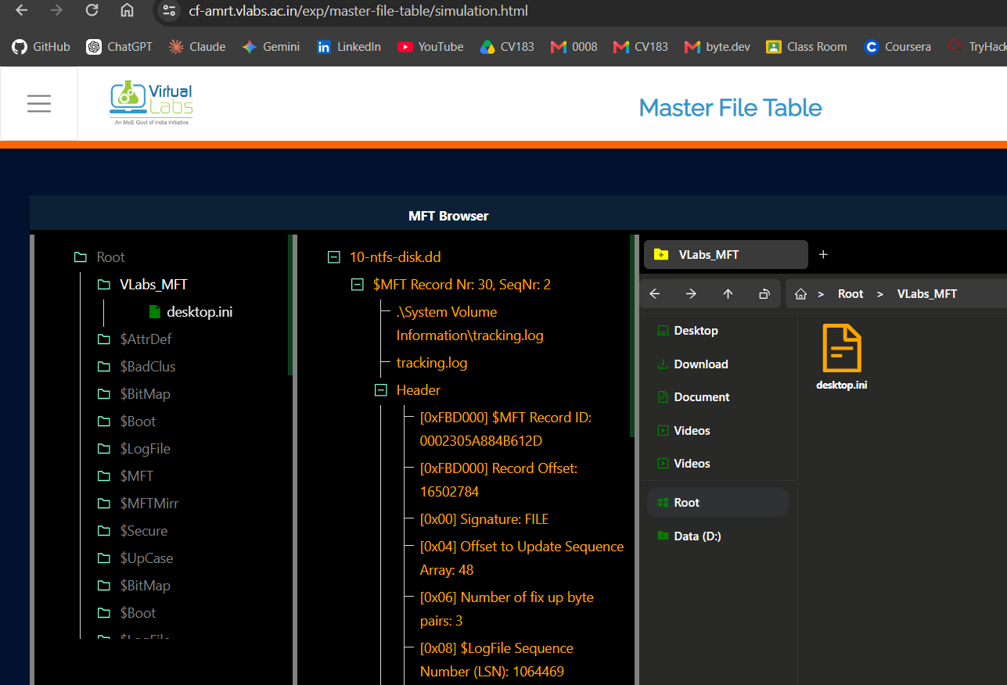

Part B — MFT Browser
1. Click 'Show MFT View' to open the MFT table alongside the file explorer view.
2. Use the switch icon to toggle between the file-explorer view and the raw hex-offset view of the MFT.
3. Observe that every file created/deleted during Part A is reflected in both the file explorer and the MFT browser.
4. In the offset panel, search for the marker text 'hjfkhdfbdbfkdfkd' to locate and highlight its hex offset inside the MFT entry — proving the data written to the deleted file is still recoverable.
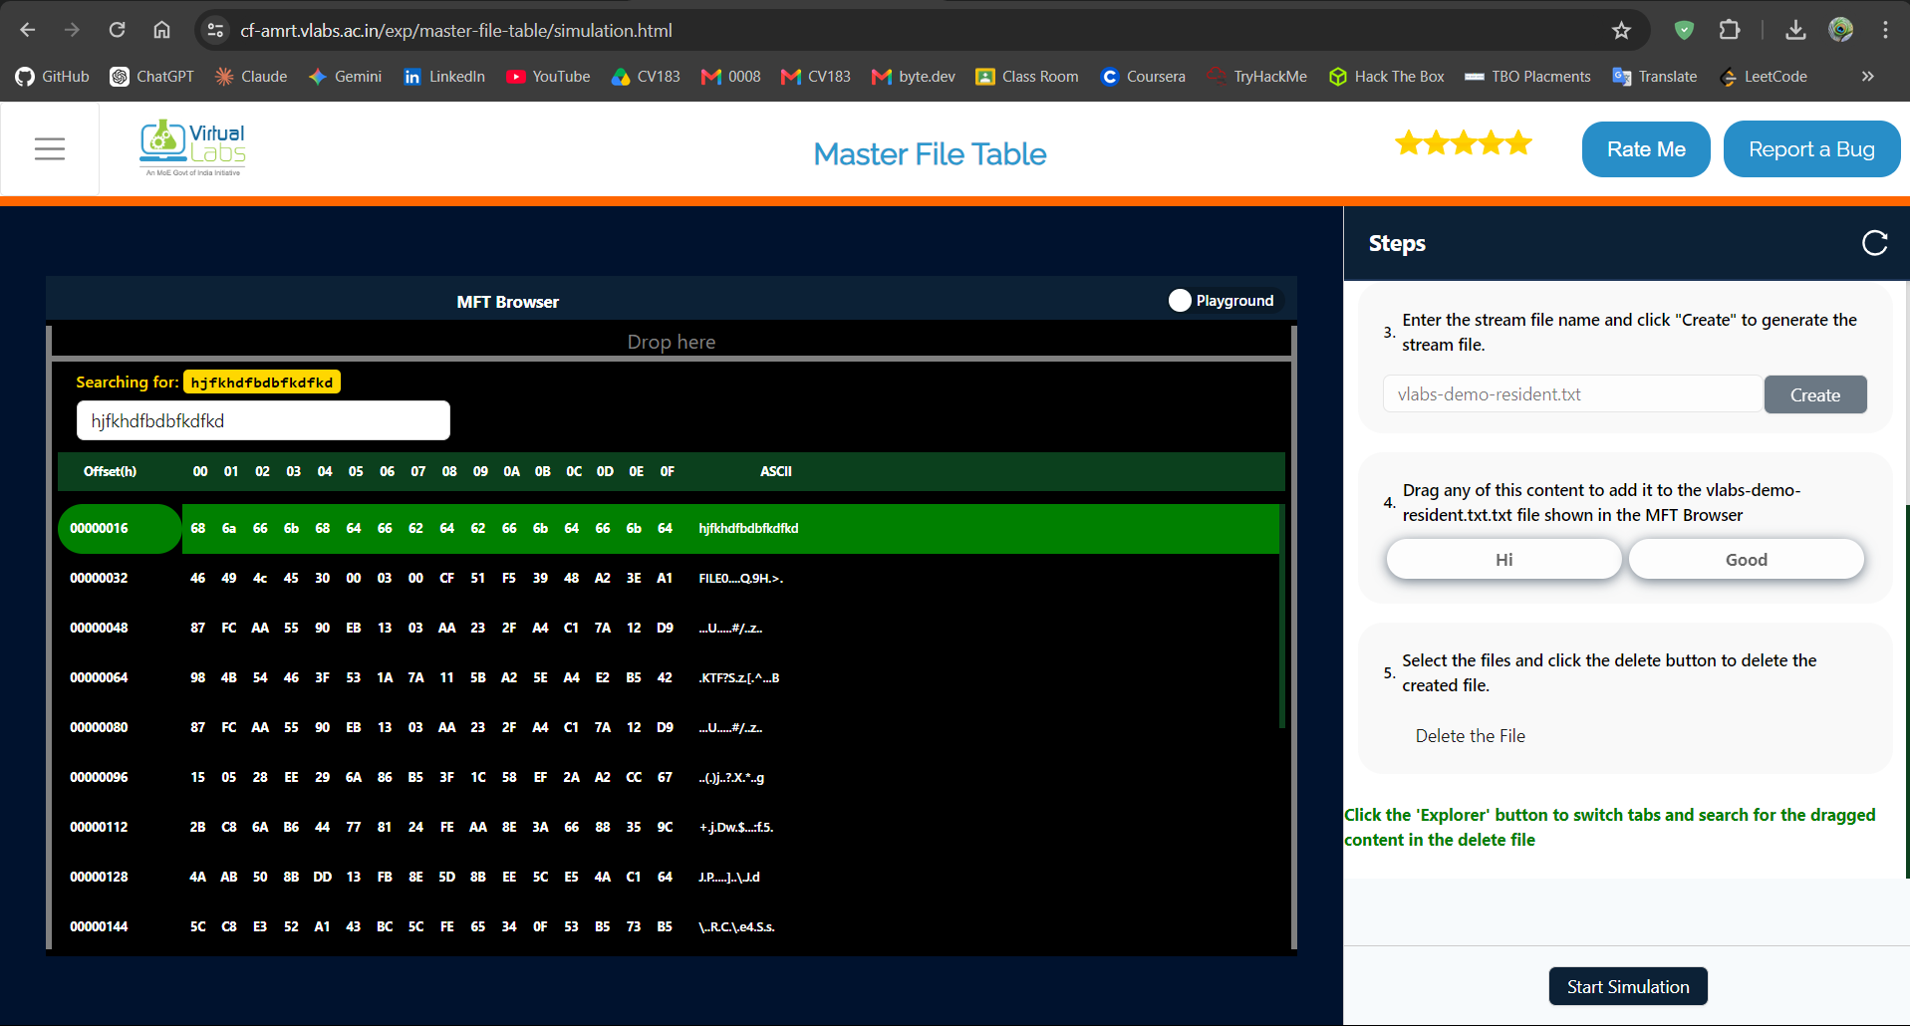
Posttest
1. After deleting a file in an NTFS file system, how can you still recover its content?
By locating the $DATA attribute in the Master File Table (MFT).
2. What is a key forensic use of the Alternate Data Streams (ADS) in an NTFS file system?
To hide additional data or malicious content within a file.
3. What is the importance of extracting the Master File Table (MFT) from a file system image during forensic analysis?
To identify suspicious files and track file activity.
4. Which NTFS attribute is crucial for determining when a file was created, modified, or accessed?
$STANDARD_INFORMATION
5. How does the $LogFile attribute assist digital forensic experts in NTFS investigations?
It maintains transactional records of file system changes.
6. Why is analyzing unallocated clusters important during NTFS forensic investigations?
They often contain fragments of deleted files that can be recovered.
Conclusion:
The practical demonstrated that the NTFS Master File Table is a valuable source of forensic evidence. MFT records preserve structured information about files and directories, including names, timestamps, attributes, allocation information, and data relationships. The experiment also showed how resident and non-resident $DATA attributes differ and how an additional Alternate Data Stream can be identified and retrieved for examination. Maintaining the screenshots in timestamp order provides a clear and auditable record of the forensic workflow.

Practical No. 4: Data Hiding and Unhiding: LSB Steganography Technique
Aim
To hide and recover text/URL data inside an image using the Least Significant Bit (LSB) technique, and to observe how the same technique can be abused by malware to smuggle a payload.
Theory
The LSB technique hides data inside an image by replacing the least-significant bit of each colour byte (Red/Green/Blue) of selected pixels with one bit of the secret data. Because changing the lowest bit alters a pixel's colour value by at most one, the modification is imperceptible to the human eye while the image file still carries the hidden payload. To recover the data, the least-significant bits are extracted in the same order they were written and reassembled back into the original text. The same mechanism can be misused by malware to embed a command-and-control URL or payload inside an otherwise ordinary-looking image.

Procedure
Part A — Hide and Reveal Text
1. Select the image in which text will be hidden.
2. Enter the text to conceal and click 'Enter', then 'Next'.
3. Click 'Convert to Binary' to convert the text into its binary representation, then 'Next'.
4. Drag each binary digit and drop it into the last bit of the Red, Green and Blue channels (or use 'Auto' once enabled) to embed all bits.
5. Click 'Encode' to embed the data, then 'Download' to save the modified image (or click 'Decode' to reverse the process).
6. Compare the original and modified images to see that only the least-significant bit of each colour byte changed.
7. Click 'Unhide Text' to extract and reveal the originally hidden message.
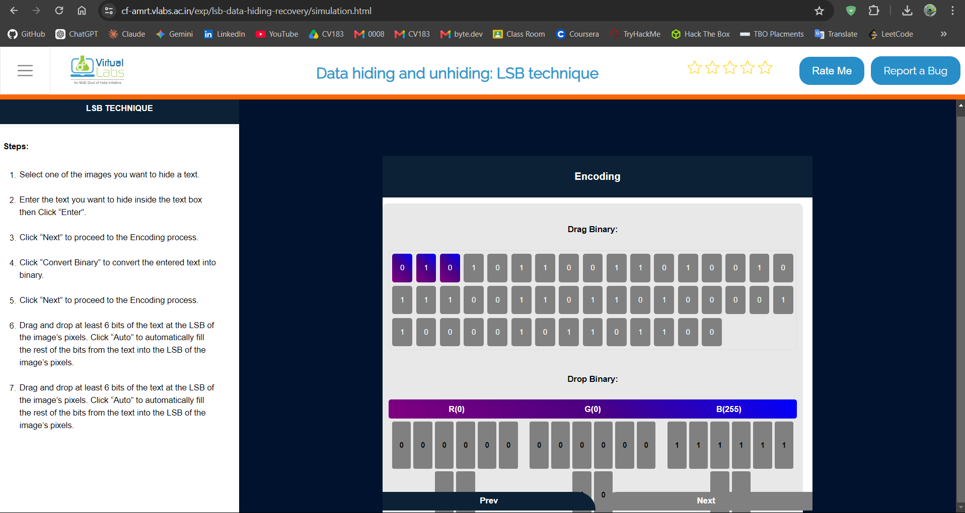

Part B — Malware-style URL Hiding (Offensive Use Case)
1. Drag an image (or a URL) into the Python input box to see LSB encoding/decoding demonstrated in code.
2. Click 'Encode' to convert a URL to binary and embed it into the image.
3. Click 'Show Image' to view the modified image, then 'Next Step' to move to decoding.
4. Click 'Decode' — the corresponding Python function is highlighted and executed to extract the hidden URL.
5. Click the decoded download link to simulate retrieving the payload (.exe) referenced by the hidden URL.
6. Click 'Execute' to simulate running the downloaded file.
7. Run the malware-detection executable to observe how such a payload would be flagged.
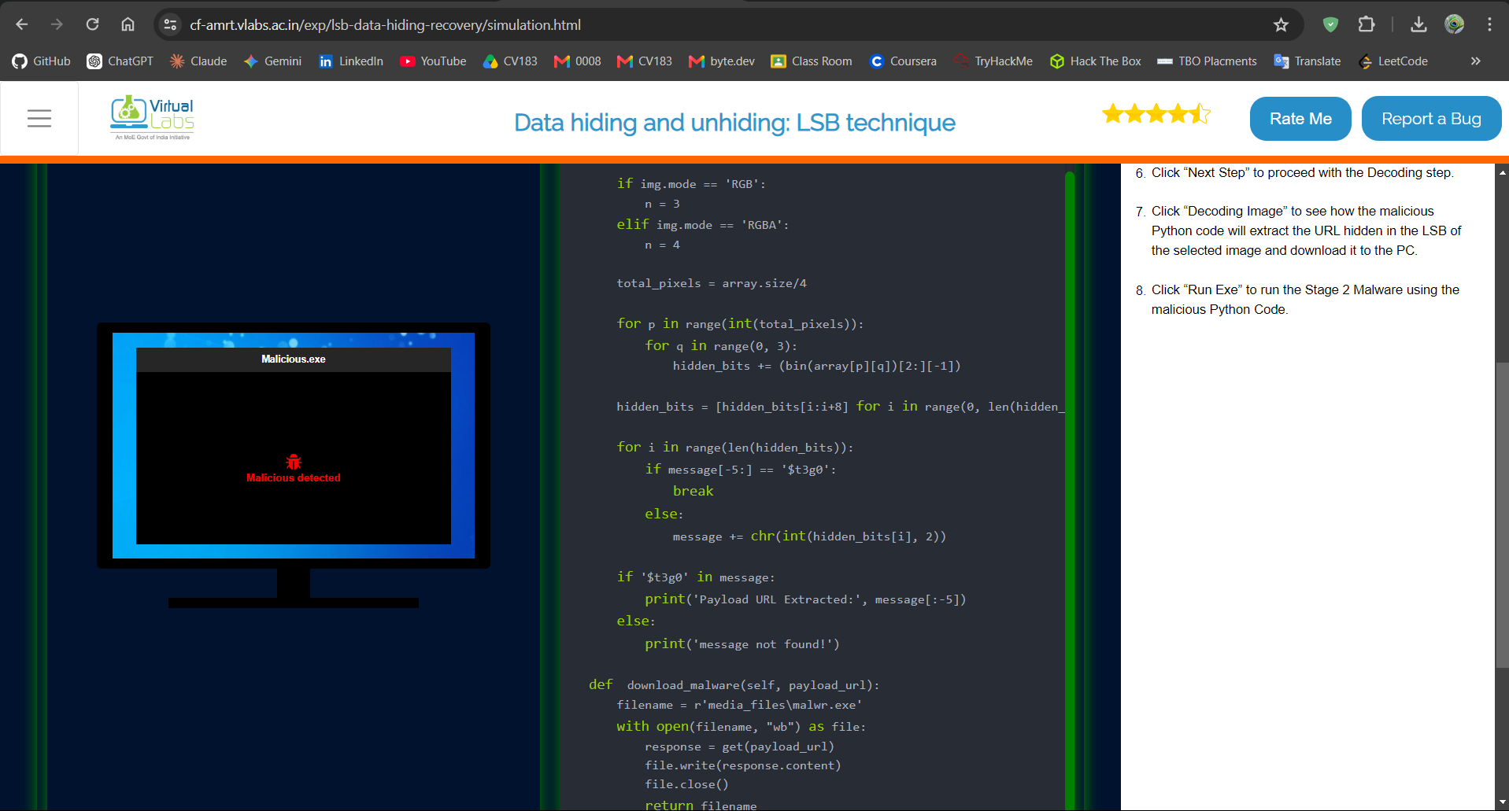

Conclusion:
Text was successfully hidden inside an image by modifying least-significant bits and later recovered intact, confirming the LSB technique preserves visual quality while carrying a hidden payload. The second part showed how the identical technique can be repurposed offensively to smuggle a malicious URL inside an image, underlining why steganalysis is an important part of malware investigation.

Practical No. 5: Identifying and Investigating Network Attacks using Wireshark

Aim
To analyse .pcap packet-capture files in Wireshark and identify signatures of common network attacks — plaintext password leaks, DNS anomalies, SYN flood, ARP poisoning and Xmas scans.

Theory
Wireshark is a packet-analysis tool that lets an investigator open a .pcap capture and inspect every packet's headers and payload. Many network attacks leave a recognisable signature in captured traffic: credentials sent in cleartext over unencrypted protocols, abnormal or spoofed DNS responses, a flood of TCP SYN packets without completed handshakes (SYN flood / DoS), forged ARP replies that redirect traffic (ARP poisoning), and TCP packets with an unusual combination of flags such as FIN+PSH+URG (Xmas scan) used for stealthy port scanning. Applying targeted display filters for each pattern lets an analyst quickly isolate the relevant packets.

Procedure
1. Click 'Wireshark' in the simulation to launch the tool.
2. From the list of scenarios, select the specific network attack you want to analyse (e.g., plaintext password leak, DNS anomaly, SYN flood, ARP poisoning, or Xmas scan).
3. Load the corresponding .pcap capture and inspect the traffic for signs of the selected attack — for example, credentials visible in cleartext.
4. Apply the appropriate Wireshark display filter for that attack type to isolate the relevant packets and confirm the finding.
5. Repeat steps 2–4 for each remaining attack scenario in the list until all five have been analysed.

Conclusion
Each of the five .pcap captures was analysed in Wireshark using attack-specific display filters, and the corresponding attack signature — a cleartext credential, an anomalous DNS response, a SYN-flood pattern, a spoofed ARP reply and an Xmas-flag scan — was successfully identified, demonstrating how packet-level analysis supports network intrusion detection and forensic investigation.

Additional Online Practice

Bandit
overthewire.org

OverTheWire Bandit is an online cybersecurity and Linux learning platform designed for beginners to understand basic Linux commands, terminal operations, and essential security concepts. It provides a series of levels where users solve practical challenges using SSH connections, file navigation, file permissions, text searching, and password discovery techniques. Each level requires finding the password to access the next level, helping learners develop practical Linux command-line and problem-solving skills.

Level 0 – Establishing SSH Connection
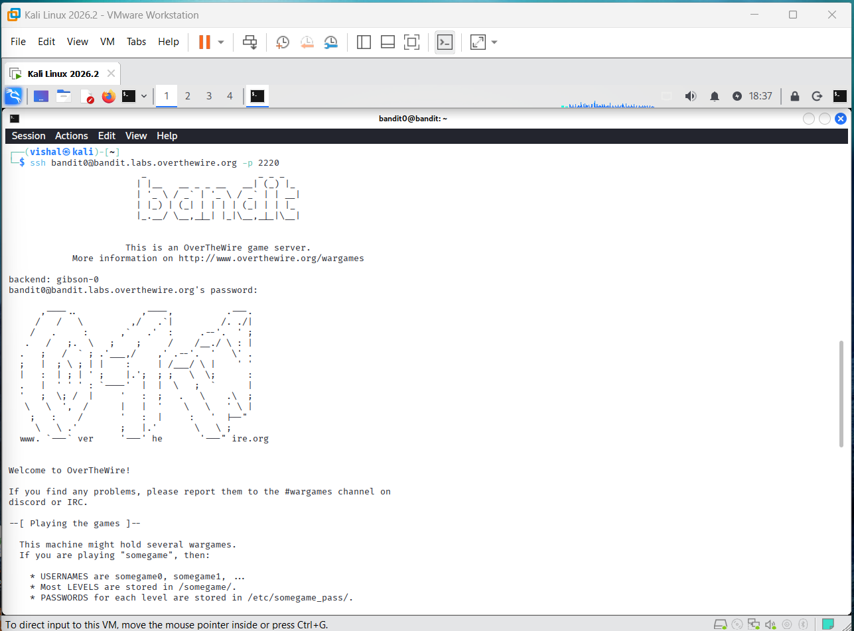

Connected to the OverTheWire Bandit server from Kali Linux using the SSH command (ssh bandit0@bandit.labs.overthewire.org -p 2220). Successfully authenticated as bandit0 and accessed the remote Linux terminal.
Established a secure SSH connection and gained access to the Bandit Level 0 environment.

Level 0 → Level 1 – Reading a File

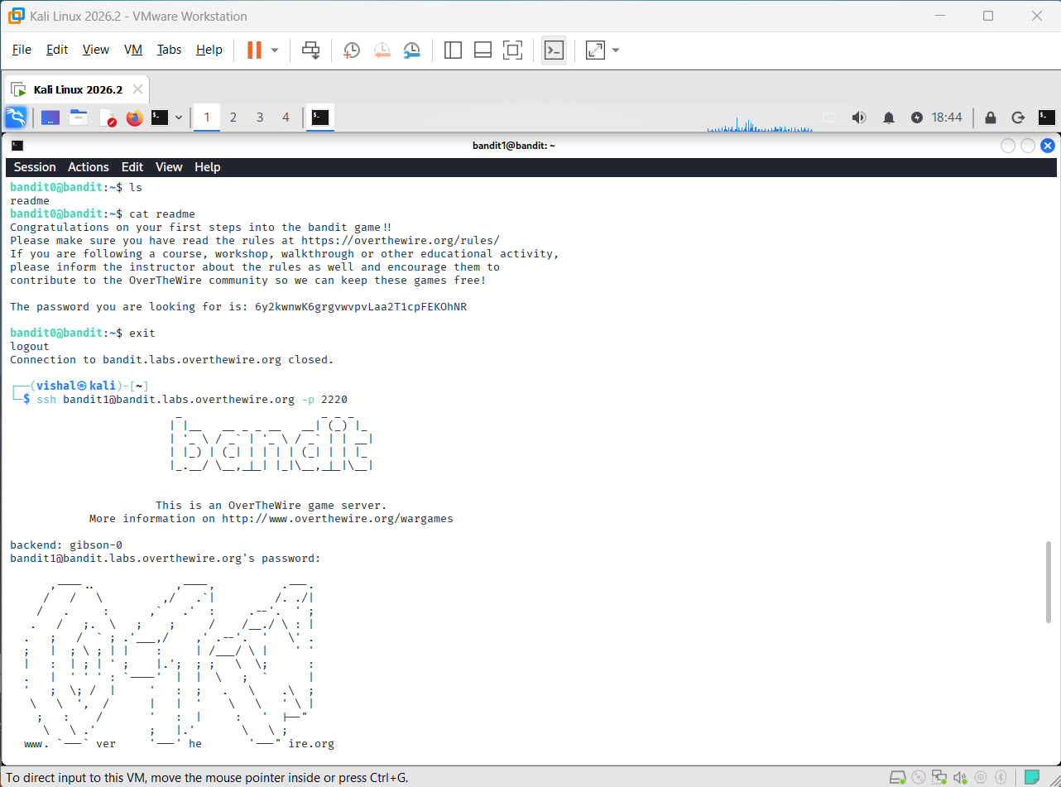

Used the ls command to list files and cat readme to read the README file in the home directory. Retrieved the password required for Level 1 and used it to initiate the next SSH login.

Successfully discovered the next level's password using basic Linux file-reading commands.

Level 1 → Level 2 – Reading a File with a Special Filename

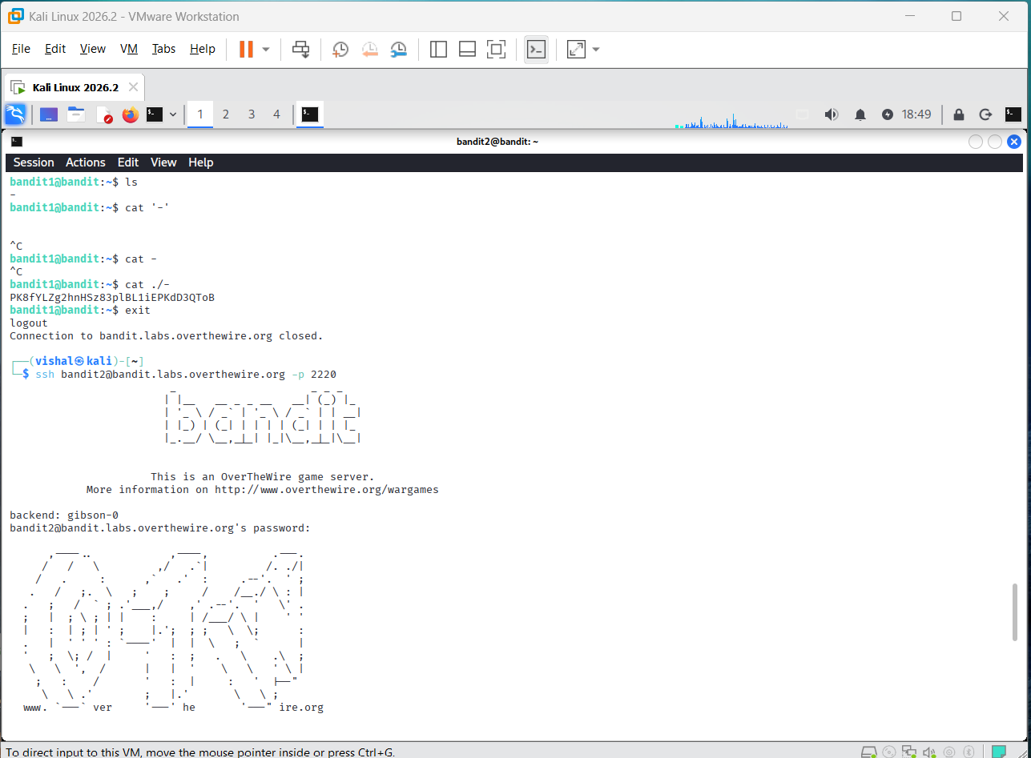

Used the ls command to identify a file named -. Initially encountered difficulty reading it because the filename was interpreted as a command-line option. Used cat ./- to display its contents and retrieve the next level's password.

Learned how to access files with special filenames using relative paths in Linux.

Level 2 → Level 3 – Handling Filenames with Spaces

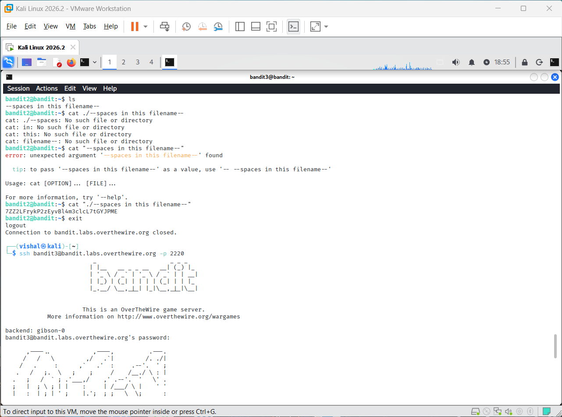

Used the ls command to identify a file containing spaces in its filename. Initially encountered errors while accessing it, then used quotation marks with cat "./--spaces in this filename--" to read the file and retrieve the next level's password.
Learned how to handle filenames containing spaces and special characters using quotation marks in Linux.

Level 3 → Level 4 – Finding Hidden Files

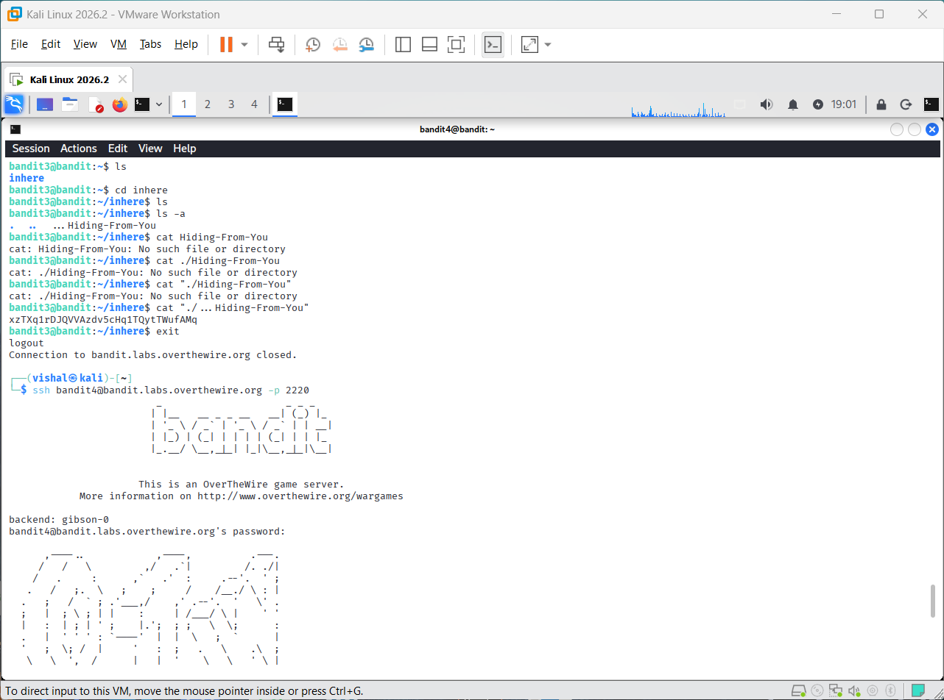

Navigated into the inhere directory using cd and used ls -a to display hidden files. Identified the hidden file ...Hiding-From-You and used the cat command to read its contents and obtain the next level's password.

Learned how to identify and access hidden files in Linux using ls -a.

Level 4 → Level 5 – Finding the Human-Readable File

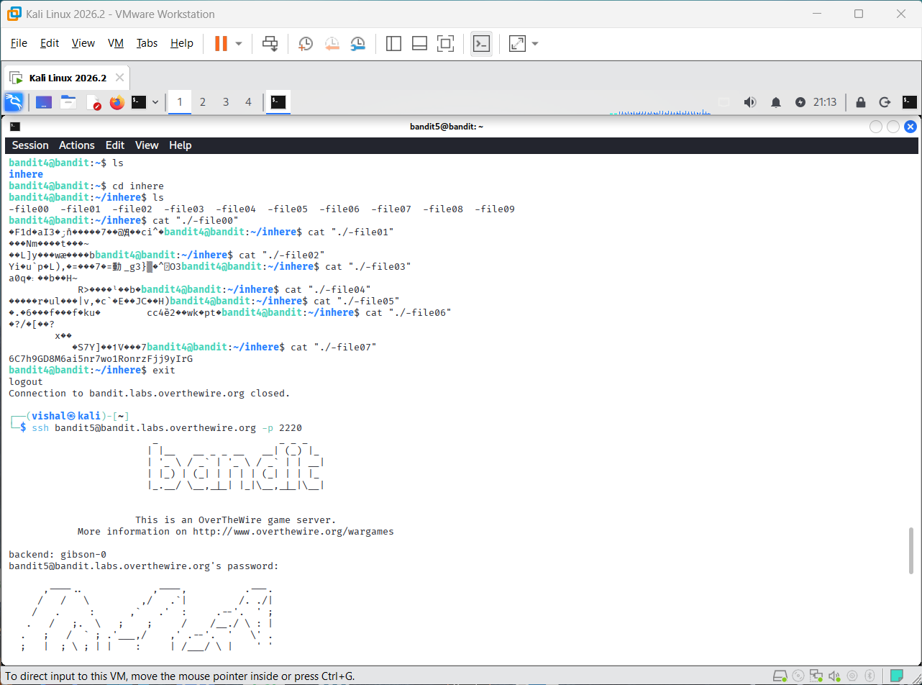

Navigated to the inhere directory and used ls to list multiple files (-file00 to -file09). Used the cat command to inspect their contents and identified -file07 as the human-readable file containing the next level's password.

Learned how to identify useful information among multiple files containing binary or non-readable data.

Level 5 → Level 6 – Finding a File Using Specific Properties

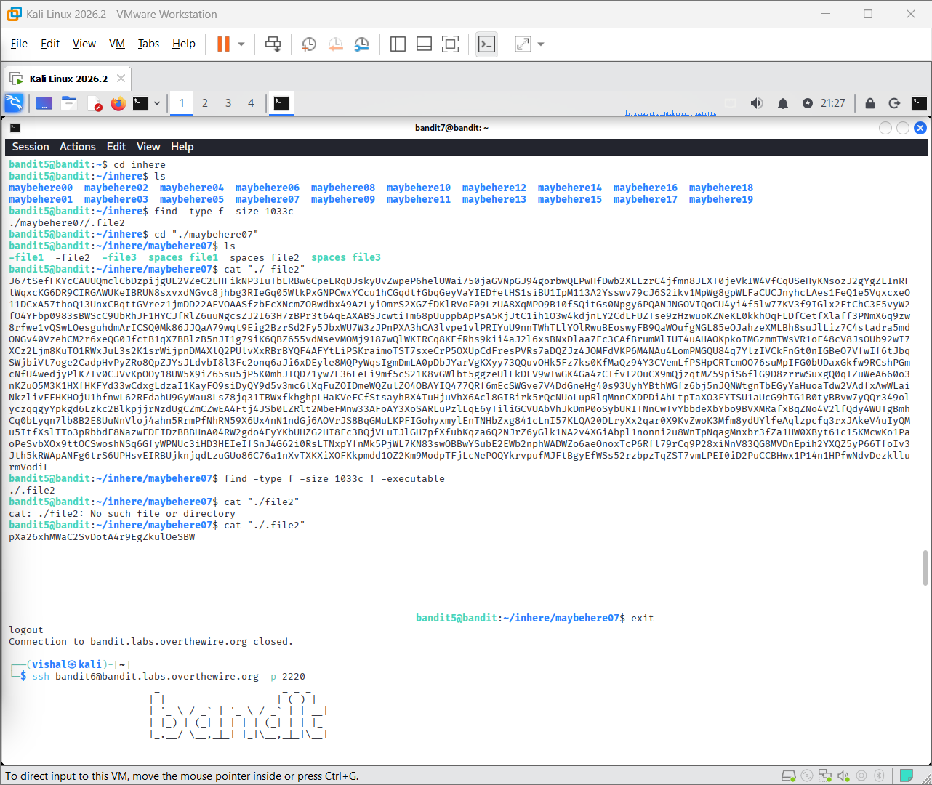

Used the find command with file-size (-size 1033c) and permission (! -executable) filters to locate the required file inside the inhere directory. Identified the correct file and used cat to read its contents and retrieve the next level's password.

Learned how to search for files using specific size and permission conditions in Linux.

Level 6 → Level 7 – Searching Files by Ownership and Size

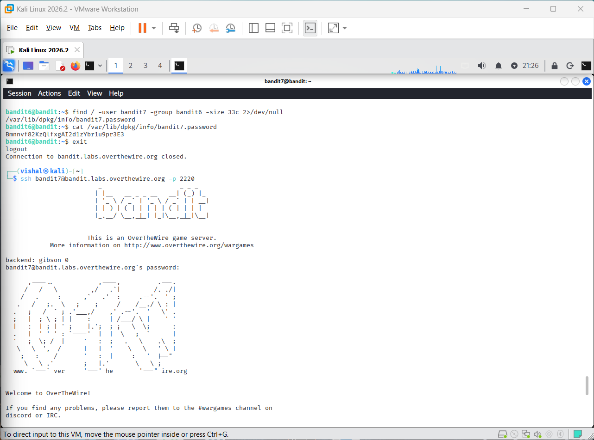

Used the find command with specific ownership conditions (-user bandit7, -group bandit6) and file size (-size 33c) to locate the required file. Redirected error messages using 2>/dev/null and read the discovered password file using cat.

Learned how to search files based on user ownership, group ownership, file size, and handle error output in Linux.

-----------------THE END-----------------

